Ro Sooihk

PI: Professor Paula Diaconescu

**Synthesis of a redox-switchable Yttrium and Indium catalysts for the ring-opening polymerization of various monomers**

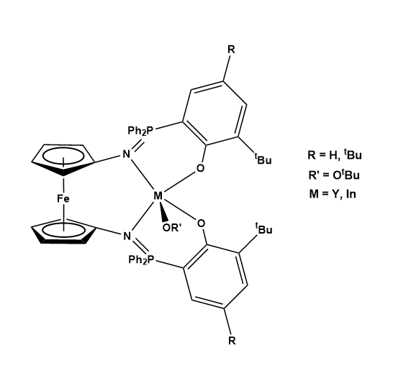

**Table of Contents**

**Table of Contents**

**Introduction page 3-4**

**Synthesis of Compounds page 4-13**

**Polymerizations with Yttrium precatalysts page 14-15**

**L-lactide Kinetic study between Yttrium precatalyts derivatives page 16**

**Y(OtBu)phosfeN(di-tert-butyl) cyclic voltammetry page 17-18**

**NMRs of compounds page 19-45**

**1H NMRS of Polymerizations page 46-70**

**Abstract**:

The ring-opening polymerization (ROP) of cyclic esters is a resourceful method for the production of polyesters. As such, there is an interest in achieving a higher degree of control over the polymerization process. Selective control can be achieved through redox-switchable catalysts, which selectively induce and inhibit the ring-opening polymerization of certain monomers. The focus of this project is the synthesis of redox-switchable yttrium and indium alkoxide complexes supported by a ferrocene-based ligand that exhibit selective reactivity towards various monomers between its oxidized and reduced forms.

**Introduction**:

Figure 1. (Switchable Polymerization Catalysts. Image from ACS Publications website on September 29, 2016. http://pubs.acs.org/doi/abs/10.1021/acs.chemrev.5b00426)

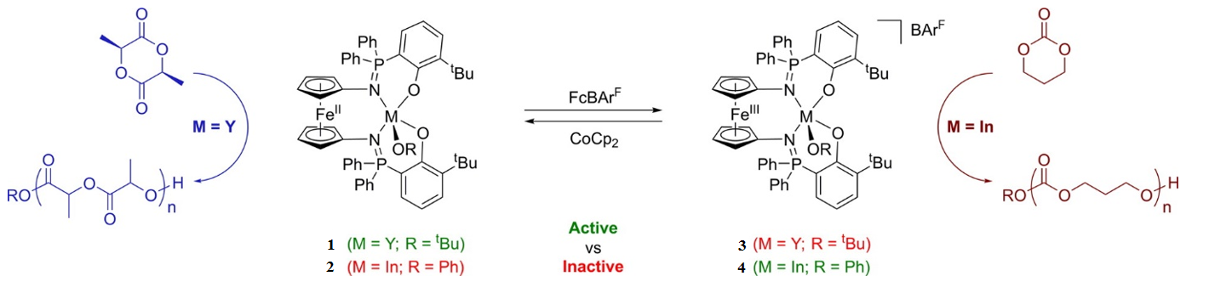

The ring-opening polymerization (ROP) of cyclic esters is a resourceful method for the production of polyesters. With the utility of these ROP materials, there is a keen interest in having a high degree of control over the polymerization process. Redox-switchable catalysis (RSC) provides this selective control by inducing and inhibiting the ROP of monomers. RSC is a method where the reactivity and selectivity of a ROP catalyst is modulated through the redox control of the supporting ligand in the metal complex.1 The goal is to synthesize a complex that displays selective reactivity for different monomers as it is switched in its oxidized and reduced catalytic complex.

This project follows research conducted by Erin Broderick in Diaconescu’s group, where Broderick was able to regulate the polymerization rates of trimethylene carbonate and L-lactide with yttrium and indium based alkoxide complexes. The metal alkoxide complexes were supported by ferrocene-based ligand which served as a remote redox switch. Diaconescu’s group synthesized an redox switchable yttrium (III) complex (**1**) which was able to selectively polymerize L-lactide in its reduced state but not in its oxidized state (**3**). This showed that the ROP of L-lactide with the yttrium complex (**1**) could be switched on and off by switching the oxidation state of the ferrocene component of the complex. The opposite behavior was observed for the indium based complex (**2**). In its oxidized state (**4**), the indium alkoxide complex (**2**) was able initiate the ROP of trimethylene carbonate but not in its reduced state.2-3

This project focuses on investigating the activities of these redox-switchable yttrium and indium alkoxide complexes supported by ferrocene-based ligands during the ROP of cyclic esters. Redox control of the supporting ligand in the metal complex allows the modulation of the reactivity and selectivity of the complex toward its ROP of different monomers. Reducing the oxidized form of the catalyst decreases the electron withdrawing ability of the phosfen ligand and enhanced the growth of the polymer. The goal of this project was to recreate complexes **1** and **2** as well as synthesizing a derivative containing an extra para tert-butyl group on the phenyl ring.

**Materials and Methods**

**General**. All 1H NMR and 31P NMR measurements were operated on Bruker AV300 and AV400 Sample Changer in Molecular Instrumentation Center of UCLA. 1H NMR spectra were obtained at 400.132 MHz. All NMR data were recorded in parts per million (δ) downfield from tetramethylsilane. Silica gel 60 F254 0.2 mm glass-backed plates were used in Thin-Layer Chromatography (TLC), and ultraviolet light and iodine were used as visual detection methods of TLC. Silica gel 60 (230-400 mesh) was used in the silica plug. All reagents were obtained from MSB 1210 and 1220.

***Synthesis of fcLi2(TMEDA)* (5)**

* Under nitrogen in a glove box, ferrocene (5.0g, 0.0269mol, 1 equivalent) was dissolved in hexanes (100mL) and mixed with 9.656mL (1.2 equivalent) of tetramethylethylenediamine (TMEDA) in a roundbottom flask. Hexanes and n-butyllithium (20mL, 2.0 equivalent) were added to an addition funnel. The contents in the addition funnel were added dropwise to the mixture in the flask over an hour. The mixture was stirred overnight and then filtered over a frit. The orange product was washed with hexanes and dried under vacuum.

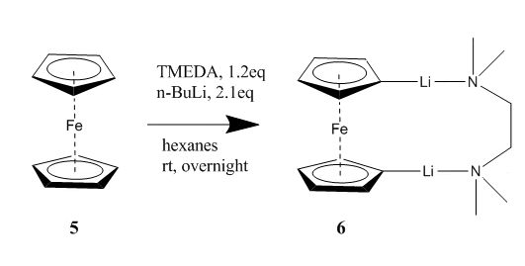

**Figure 2. fcLi2(TMEDA)**

***Synthesis of 1,1’-dibromoferrocene*** **(6)**

* In a glovebox fcLi2(TMEDA) (3.10g, 1 equivalent) was diluted in 50mL of diethyl ether in a round bottom flask. Tetrabromoethane (2.86mL, 2.2 equivalent) (TBE), was diluted in Et2O in an addition funnel and attached to the round bottom flask. The apparatus was taken out of the glove box and the flask was cooled to -78˚C with a dry ice/acetone bath. TBE was slowly added dropwise and the reaction mixture was kept cold for 6 hours. Afterwards the mixture was stirred overnight at room temperature. The mixture was then diluted with water (150mL). The mixture was stirred for additional 30 minutes before being extracted with Et2O (3x). The organic layer was dried with magnesium sulfate and filtered over celite. The solvent was removed by vacuo and the product was redissolved with methanol to a concentrated solution. The product was then placed in a freezer at -15˚C overnight for recrystallization.

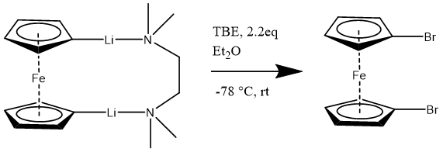

**7**

**6**

**Figure 3. 1,1’dibromoferrocene**

***Synthesis of 1,1’-diazidoferrocene* (8)**

-In the glovebox with the lights out(light sensitive reaction), dibromoferrocene **(7)** (3.72g, 1 equivalent) and CuCl (2.41g, 2.1 equivalents) were dissolved in ethanol. A solution of NaN3 (3.53g, 4 equivalents) dissolved with 20mL of water was added to the ethanol solution. The flask was covered with aluminum foil and stirred for 48 hours. Afterwards 150mL of water was added to the reaction mixture and stirred for an additional hour. The product was extracted with Et2O (x3) and washed with di water. The combined organic layers were dried with magnesium sulfate and filtered over celite. Solvent was removed by vacuo. The product was dissolved with pentane (10mL) and placed in a freezer overnight at -15˚C for recrystallization.

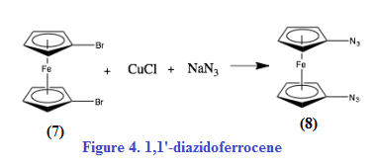

***Synthesis of 2-bromo-4,6-di-tert-butylphenol***

* 2,4-di-tert-butylphenol (10.0g, 1 equivalent) was dissolved with 150mL of acetonitrile and cooled to 0˚C. N-bromosuccinmide (9.10g, 1.05 equivalents) was added to the mixture portionwise. The mixture was stirred overnight and allowed to warm to room temperature slowly. For the workup, saturated aqueous solution of sodium bisulfite was added to the mixture. The mixture was filtered over celite and the product was extracted with petroleum ether (x4). Organic layer was washed with water and dried with magnesium sulfate. Organic layer was filtered over celite and the solvent was removed by vacuo.

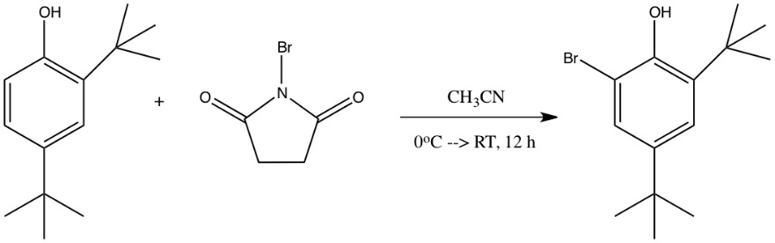

**Figure 5. 2-bromo-4,6-di-tert-butylphenol**



***Synthesis of 2,4-di-tert-butyl-6-(diphenylphosphanyl)phenol***

* In a glove box, 2-bromo-4,6-di-tert-butylphenol (1.50g, 1 equivalent) was diluted with 15mL of Et2O and cooled to -78˚C. n-Butyl lithium (5.50mL, excess 2 equivalents) was added to the mixture dropwise at -78 ˚C. The mixture was stirred for 30 minutes at room temperature. Chlorodiphenyphosphine (0.946mL) was added to the mixture dropwise at -78˚C. The mixture was stirred at room temperature for 20 hours. For the workup, the mixture was brought outside the box and treated with aqueous NaH2PO4 (0.1M) and the organic layer was filtered over celite. Methanol was added to the product and the solution was reduced in vacuo until a quarter of solvent remained. The solution was placed in a freezer at -15˚C for solid to precipitate out. White precipate was washed with methanol.

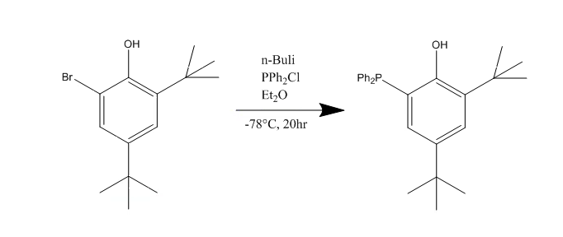



**Figure 6. 2,4-di-tert-butyl-6-(diphenylphosphanyl)phenol**

***Synthesis of PhosfeNNN(di-tert-butyl)***

* In the glove box under nitrogen, 0.349g of fc(N3)2 **(8)** (1 equivalent) was dissolved in hexanes was added dropwise to a solution of 2-diphenylphosphino-4,6-di-tert-butylphenol (**11**) (1.01g, 2 equivalents) within Et2O. The mixture was stirred for 1 hour and placed in a freezer overnight at -40˚C. For the workup, the mixture was filtered over a frit and the red solids were washed with hexanes.
* ****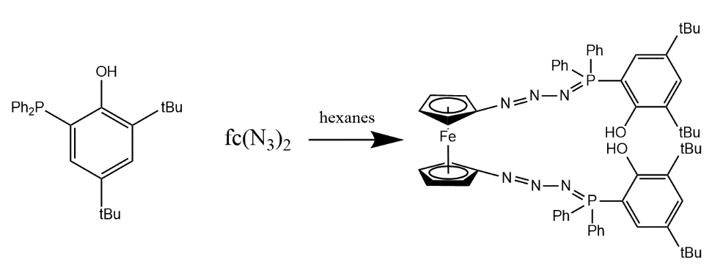

**Figure 7. PhosfeNNN(2,4-di-tert-butyl)**

***Synthesis of H2phosfen(2,4-di-tert-butyl)***

* In the glove box under nitrogen, 1.20g (1 equivalent) of PhosfeNNN(di-tert-butyl) was dissolved with toluene and transferred to a Schlenk flask . The Schlenk flask was brought outside the glove box and placed on an oil bath. The mixture was heated to 50˚C and stirred for 6 hours. After 6 hours, the Schlenk flask was brought back into the glove box. The mixture was filtered over a frit, washed with hexanes and dissolved in minima toluene. A hexane bilayer was gently placed on top and the product was recrystallized in a freezer at -40˚C overnight. The solvent was decanted and the crystals were washed with hexanes and dried in vacuo. Obtained 676mg (59% yield) of yellow product.

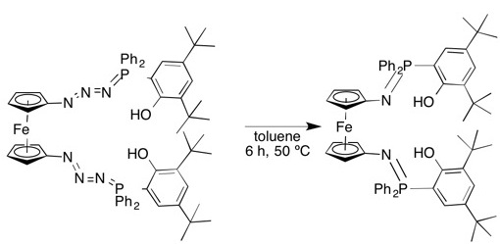

**Figure 8. H2phosfen(2,4-di-tert-butyl)**

***Synthesis of YCl(phosfen(2,4-di-tBu))***

* Under nitrogen in a glove box, H2phosfen(200mg, 1 equivalent) was dissolved in tetrahydrofuran (THF) was added dropwise to a solution containing NaH (96.7mg, 20 equivalents) within THF. The mixture was stirred for 2 hours and then filtered over celite. The mixture was then added dropwise to a solution containing 135.2mg(1.5 equivalents) of YCl3(THF)3.5 within THF. The mixture was stirred for 2 hours and then filtered through celite. The THF was removed in vacuo. The yellow solid was dissolved in toluene and filtered through celite three times. Toluene was removed via vacuo and hexanes were added to the product and shaken. The vial was placed in a freezer for 30 minutes and hexanes was decanted out. Repeated washing two more times.

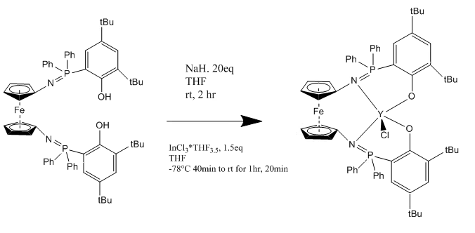

**Figure 9. YCl(phosfen(2,4-di-tBu))**

***Synthesis of InCl(phosfen(2,4-di-tBu))***

* Under nitrogen in a glove box, H2phosfen(300mg, 1 equivalent) was dissolved in tetrahydrofuran (THF) was added dropwise to a solution containing NaH (144.1mg, 20 equivalents) within THF. The mixture was stirred for 2 hours and then filtered over celite. The mixture was then added dropwise to a solution containing 214.6mg(1.5 equivalents) of InCl3(THF)3.5 within THF at -78.˚C The mixture was stirred for 30 minutes at -78 ˚C and 90 minutes at room temperature. The mixture was then filtered through celite. Solvent was removed in vacuo and the yellow solid was dissolved in toluene. The solution was filtered through celite and the THF was removed in vacuo. The yellow solid was dissolved in toluene and filtered through celite three times. Toluene was removed via vacuo and hexanes were added to the product and shaken. The vial was placed in a freezer for 30 minutes and hexanes was decanted out. Repeated washing two more times.

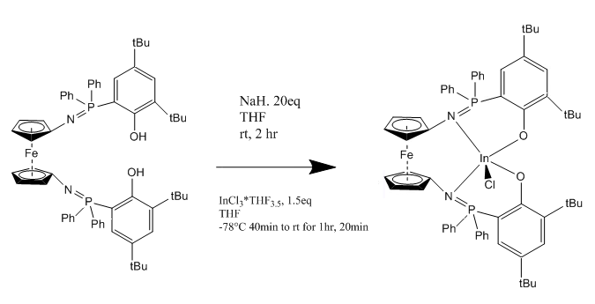

**Figure 10. InCl(phosfen(2,4-di-tBu))**

***Synthesis of (2-Y(OtBu), phosfen= 1,1’–di(2,4-di-tert-butyl-6- diphenylphosphiniminophenoxy)ferrocene***

* Under nitrogen in a glove box, 90.1mg (1 equivalent) of YCl(phosfen(2,4-di-tBu)) was dissolved in Et2O and cooled to 0˚C. KOtBu (20.1mg, 2.0 equivalents) was dissolved in Et2O in cooled to 0˚C. The KOtBu solution was added dropwise to the solution containing YCl(phosfen(2,4-di-tBu)) at 0˚C and stirred overnight and gradually warmed to room temperature. The mixture was then filtered over celite and dissolved in toluene. The mixture was then filtered again with celite and the solvent was removed in vacuo. The yellow solid was dissolved in toluene and filtered through celite three times. Toluene was removed via vacuo and hexanes were added to the product and shaken. The vial was placed in a freezer for 30 minutes and hexanes was decanted out. Repeated washing two more times.
*  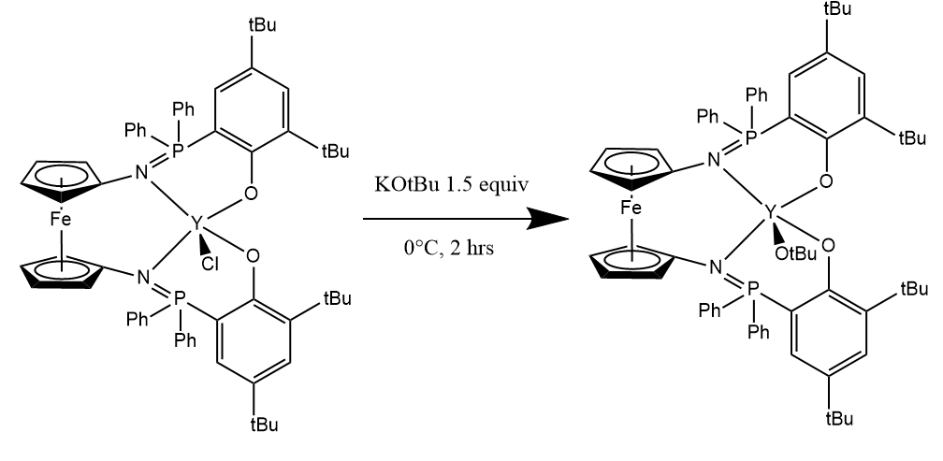

**Figure 11. 2-Y(OtBu)**

***Synthesis of oxidized 2-Y(OtBu)phosfeN(di-tert-butyl)***

* Under nitrogen in a glove box, 4.61mg of 2-Y(OtBu)phosfeN(di-tert-butyl) was dissolved in 2mL of benzene with 3.50mg (1 equivalent) of AcFcBArF. The mixture was stirred for 15 minutes and then filtered over celite. Solvent was removed and dissolved with toluene then filtered over celite. Removed toluene via vacuo and washed with hexanes.

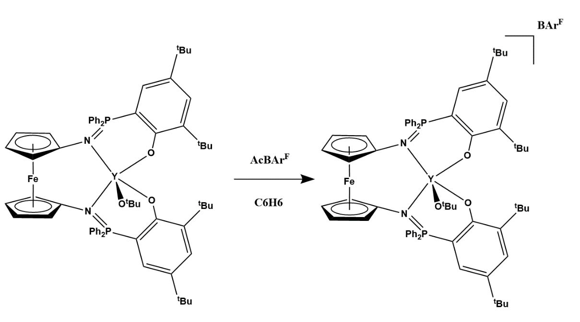

***Synthesis of 2-bromo-6-(tert-butyl)phenol***

* *O*-(*tert*-butyl)phenol (1 eq, 2.00g or 2.04ml) and diisopropylamine (0.1 eq, 0.135g or 0.190ml) were mixed with about 250 mL of dichloromethane. A Soxhlet extractor with a thimble containing NBS (1 eq, 2.34 g) was attached followed by a condenser under nitrogen. The reaction was refluxed for 16 hours. The refluxed mixture was treated with 2 M H2SO4 and the organic layer was separated and dried with MgSO4 and filtered through celite. Solvent was removed in vacuo and the product was purified by column chromatography with hexanes:EtOAc (40:1).

******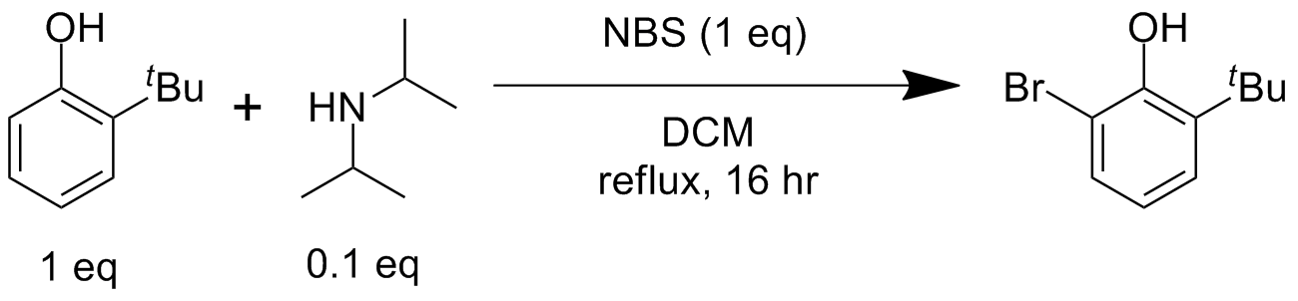

**Figure 13. 2-bromo-6-(tert-butyl)phenol**

***Synthesis of 2-(tert-butyl)-6-(diphenylphosphino)phenol***

* In a glove box, n-BuLi (7.5mL, 2.0 equiv) was added dropwise to 2-bromo-6-(tert-butyl)phenol (2.07g, 1 equiv) within Et2O at -75°C. After stirring the micture for 2 hours, Ph2PCl (1.78mL, 1 equiv) was added dropwise to the mixture at -78°C. The mixture was stirred overnight at rt. For the workup the mixture was treated with sat. NH4Cl and the organic layer was dried with MgSO4. The organic layer was filtered over celite and the solvent was removed in vacuo. The product was purified through a column (100:1; hexanes:ethyl acetate).

******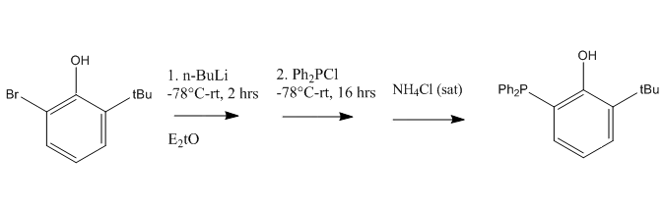

**Figure 14. 2-(tert-butyl)-6-(diphenylphosphino)phenol**

***Synthesis of PhosfeNNN(mono-tert-butyl)***

* In a box, (0.513g, 1 equiv) 1,1-diazidoferrocene was dissolved in hexanes and added dropwise in the dark to (1.28g, 2 equiv) 2-diphenylphosphino-6-tBu phenol within hexanes. The mixture was stirred for 1 hour. The red product was collected by a frit and washed with hexanes.

**********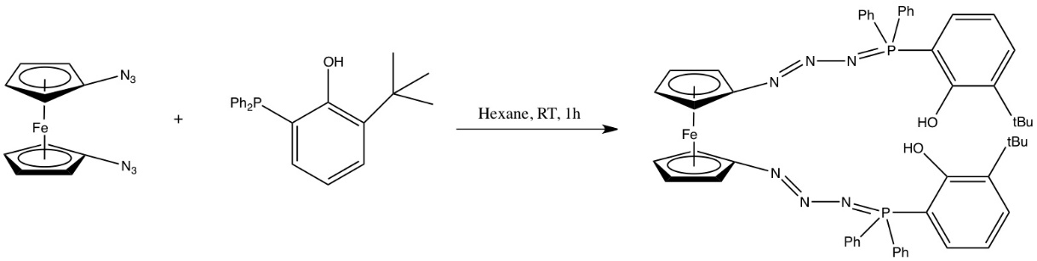

**Figure 15. PhosfeNNN(mono-tert-butyl)**

***Synthesis of H2phosfen(mono-tert-butyl)***

* In the glove box under nitrogen, (1 equivalent) of PhosfeNNN(mono-tert-butyl) was dissolved with toluene and transferred to a Schlenk flask . The Schlenk flask was brought outside the glove box and placed on an oil bath. The mixture was heated to 50˚C and stirred for 6 hours. After 6 hours, the Schlenk flask was brought back into the glove box. The mixture was filtered over a frit, washed with hexanes and dissolved in minima toluene. A hexane bilayer was gently placed on top and the product was recrystallized in a freezer at -40˚C overnight. The solvent was decanted and the crystals were washed with hexanes and dried in vacuo.

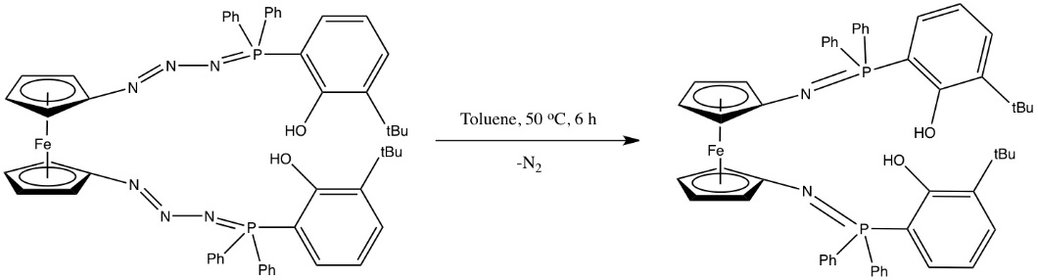



**Figure 16 . *H2phosfen(mono-tert-butyl)***

***Synthesis of YCl(phosfen(2-tBu))***

* Under nitrogen in a glove box, H2phosfen(200mg, 1 equivalent) was dissolved in tetrahydrofuran (THF) was added dropwise to a solution containing NaH (109mg, 20 equivalents) within THF. The mixture was stirred for 2 hours and then filtered over celite. The mixture was then added dropwise to a solution containing 152.5mg(1.5 equivalents) of YCl3(THF)3.5 within THF. The mixture was stirred for 2 hours and then filtered through celite. Solvent was removed in vacuo and the yellow solid was dissolved in toluene. Filtered this solution through celite and THF was removed in vacuo. The yellow solid was dissolved in toluene and filtered through celite three times. Toluene was removed via vacuo and hexanes were added to the product and shaken. The vial was placed in a freezer for 30 minutes and hexanes was decanted out. Repeated washing two more times.

 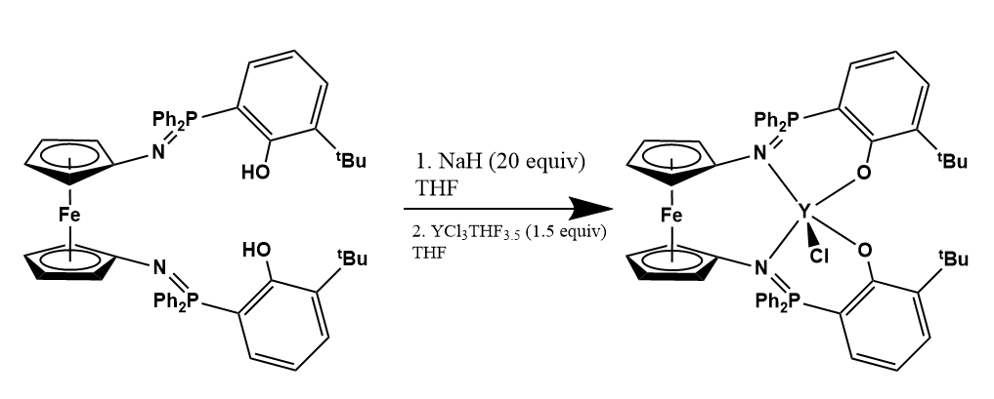

**Figure 17. YCl(phosfen(2-tBu))**

***Synthesis of (1-Y(OtBu), phosfen= 1,1’–di(2-tert-butyl-6- diphenylphosphiniminophenoxy)ferrocene***

* Under nitrogen in a glove box, 90.1mg (1 equivalent) of YCl(phosfen(2,4-di-tBu)) was dissolved in Et2O and cooled to 0˚C. KOtBu (20.0mg, 2.0 equivalent) was dissolved in Et2O in cooled to 0˚C. The KOtBu solution was added dropwise to the solution containing YCl(phosfen(2,4-di-tBu)) at 0˚C and stirred overnight and gradually warmed to room temperature. The mixture was then filtered over celite and dissolved in toluene. The mixture was then filtered again with celite and the solvent was removed in vacuo. The yellow solid was dissolved in toluene and filtered through celite three times. Toluene was removed via vacuo and hexanes were added to the product and shaken. The vial was placed in a freezer for 30 minutes and hexanes was decanted out. Repeated washing two more times.

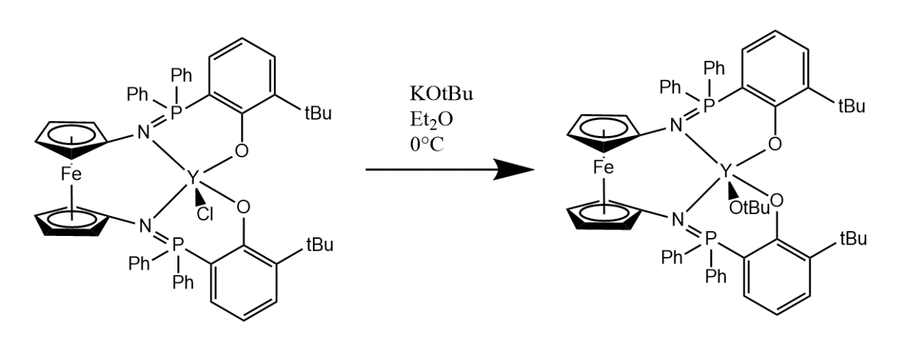

**Figure 18. 1-Y(OtBu)**

***Polymerizations with Yttrium precatalysts (reduced and oxidized forms)***



|  |  |  |
| --- | --- | --- |
| **R** | **H** | **tBu** |
| Lactide | 100% 2 hours | 100% 2 hours |
| Lactide (oxidized) | 0% 2 hours | 0% 2 hours |
| Caprolactone | 100% 5 minutes | 100% 5 minutes |
| Caprolactone (oxidized) | 100% 5 minutes | 100% 5 minutes |
| Cyclohexene Oxide | 0% >2 hours | 0% >2 hours |
| Cyclohexene Oxide (oxidized) | 0% >2 hours | 100% 2 hours |
| Trimethylene Carbonate | 100% 3 minutes | 100% 3 minutes |
| Trimethylene Carbonate (oxidized) | 100% 5 minutes | 100% 5 minutes |
| Styrene Oxide | 0% >3 hours | 0% >3 hours |
| Styrene Oxide (oxidized) | 0% >3 hours | 0% >3 hours |
| Propylene Oxide | 0% >3 hours | 0% >3 hours |
| Propylene Oxide (oxidized) | 0% >3 hours | 0% >3 hours |
| beta-Butyrolactone | 100% 2 hours | 100% 2 hours |
| beta-Butyrolactone (oxidized) | 0% >2 hours | 0% >2 hours |

*Conditions:*

All polymerizations were done at room temperature except trimethylene oxide polymerizations which were done at -78°C. 2 mL of benzene were used as solvent for each polymerization.

Quantity: precatalyst (4.61mg, 1 equivalent), monomer (100 equivalents) and trismethoxybenzene (standard, 20 equivalents)

(0.2mol monomer/L) x (1L/1000mL) x (2mLC6H6) x (1x10-3) x (mw in grams of compound) = amount of precatalyst needed for one polymerization

Procedure: Added precatalyst to mixture of TMB and monomer within 2 ml of benzene at desired temperature. Took 0.2 ml aliquots at each time point. Added hexanes to each aliquot at each time point and removed solvent in vacuo.

***L-lactide Kinetic study between Yttrium (mono-tert-butyl) and (di-tert-butyl) derivative***

|  |  |  |
| --- | --- | --- |
|  | **di-tert-butyl** | **mono-tert-butyl** |
| **3 minutes** | 21% | 15% |
| **9 minutes** | 31% | 25% |
| **11 minutes** | 39% | 32% |
| **14 minutes** | 50% | 35% |
| **20 minutes** | 58% | 44% |
| **25 minutes** | 67% | 50% |
| **30 minutes** | 71% | 54% |
| **35 minutes** | 78% | 60% |
| **45 minutes** | 85% | 68% |
| **60 minutes** | 94% | 81% |
| **90 minutes** | 97% | 91% |
| **120 minutes** | 99% | 95% |

**Y(OtBu)phosfeN(di-tert-butyl) cyclic voltammetry**

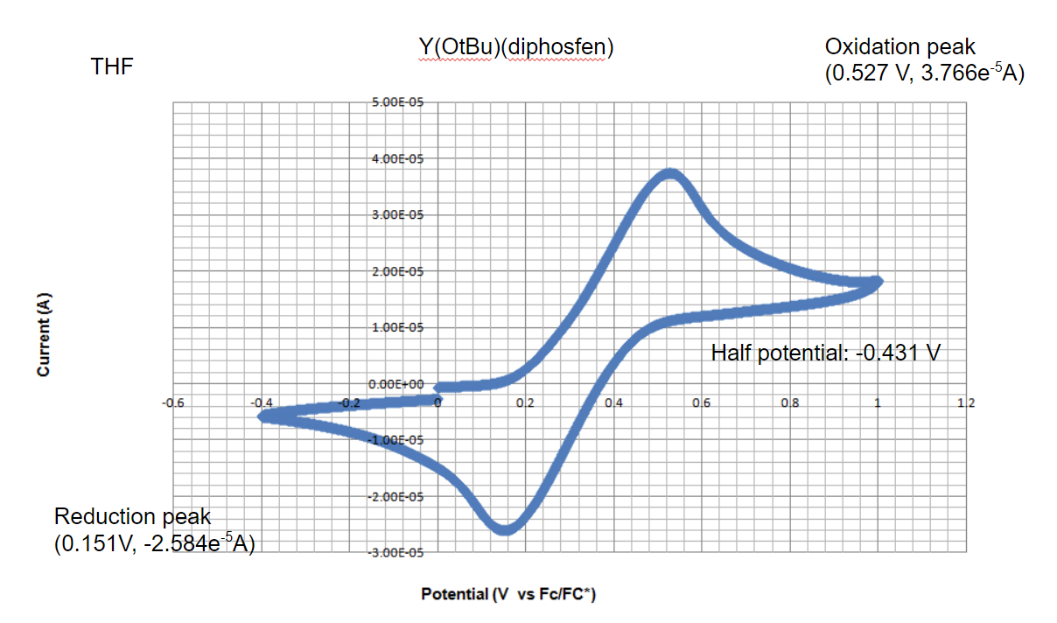

Conditions:

Instrument Model: CHI630D

Init E (V) = 0

High E (V) = 1

Low E (V) = -0.4

Final E (V) = 0

Init P/N = P

Scan Rate (V/s) = 0.1

Segment = 3

Sample Interval (V) = 0.001

Quiet Time (sec) = 2

Sensitivity (A/V) = 1e-5

**CV with yttrium compound and ferrocene**

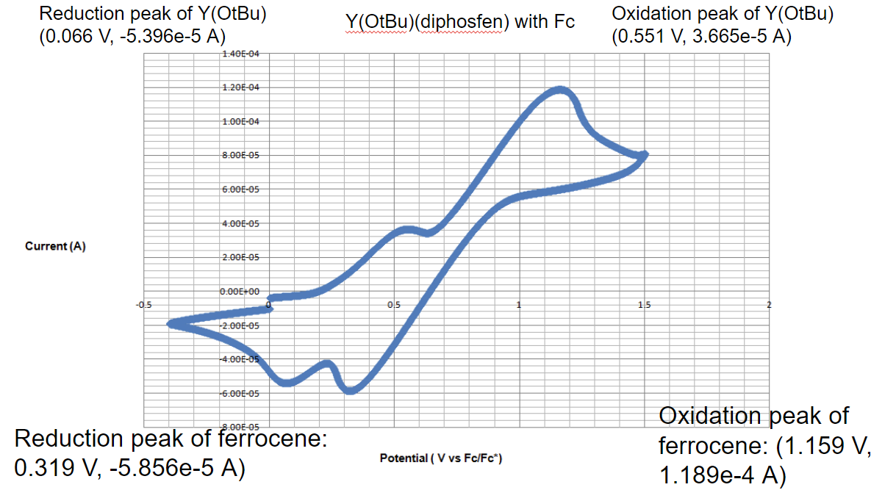

Conditions:  
Init E (V) = 0

High E (V) = 1.5

Low E (V) = -0.4

Final E (V) = 0

Init P/N = P

Scan Rate (V/s) = 0.1

Segment = 3

Sample Interval (V) = 0.001

Quiet Time (sec) = 2

Sensitivity (A/V) = 1e-4

1H NMR of Dibromoferrocene

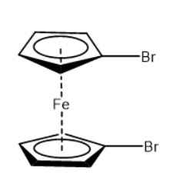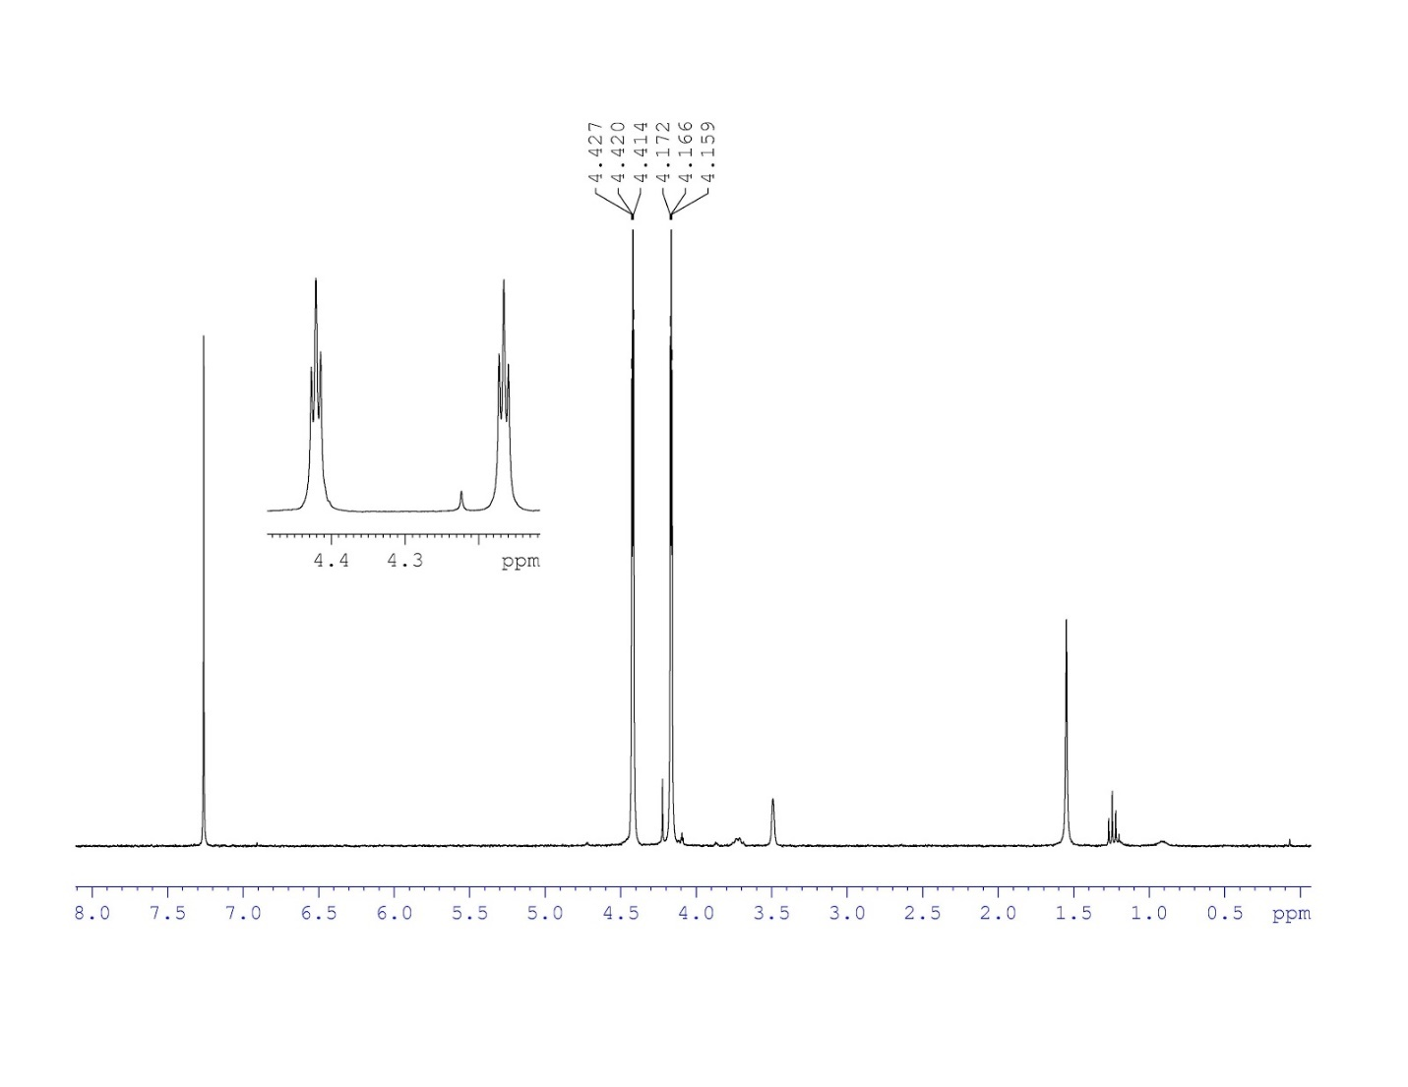

1H NMR (300 MHz, CDCl3) δ: 4.17 (8H, t, H1); 4.20 (8H, t, H2)

1H NMR of diazidoferrocene

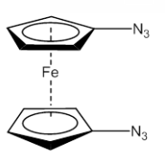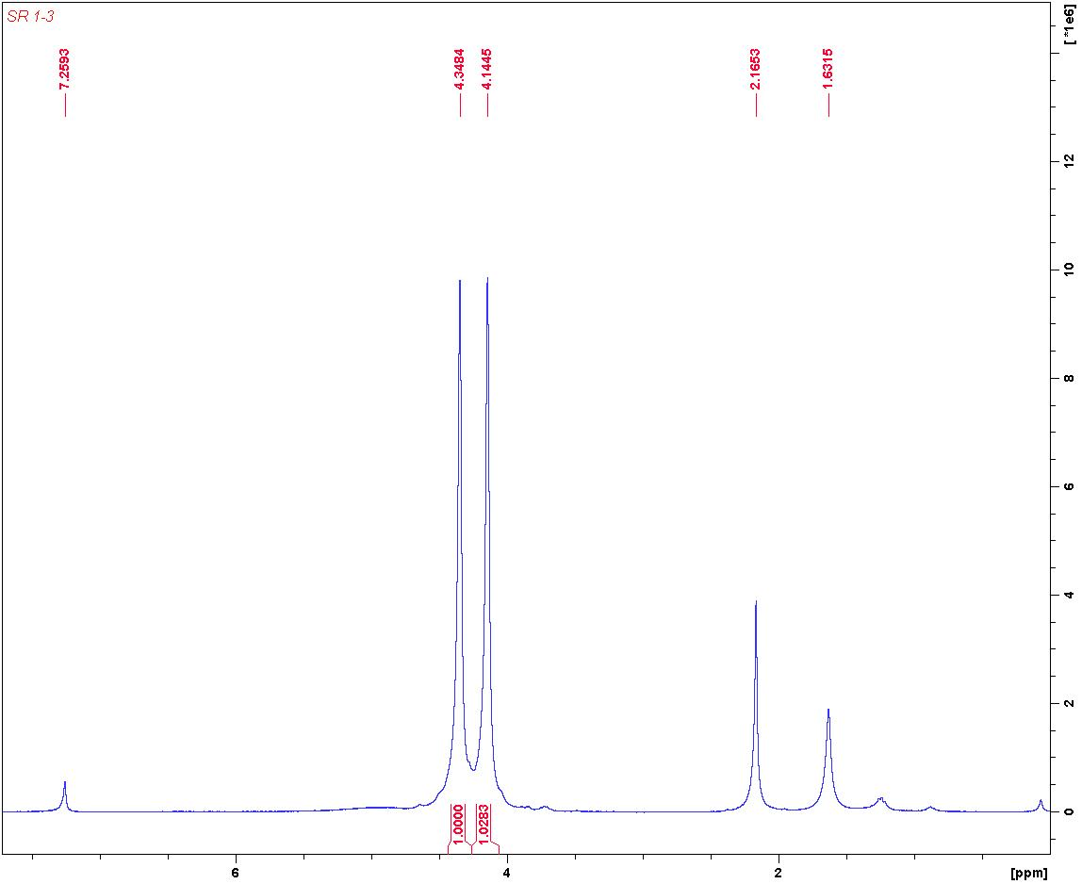

1H NMR (300 MHz, CDCl3) δ: 4.15 (8H, t, H1); 4.35 (8H, t, H2)

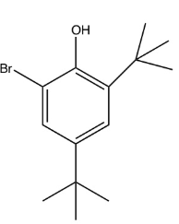1H NMR of 2-bromo-4,6-di-tert-butylphenol

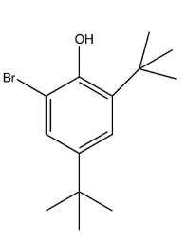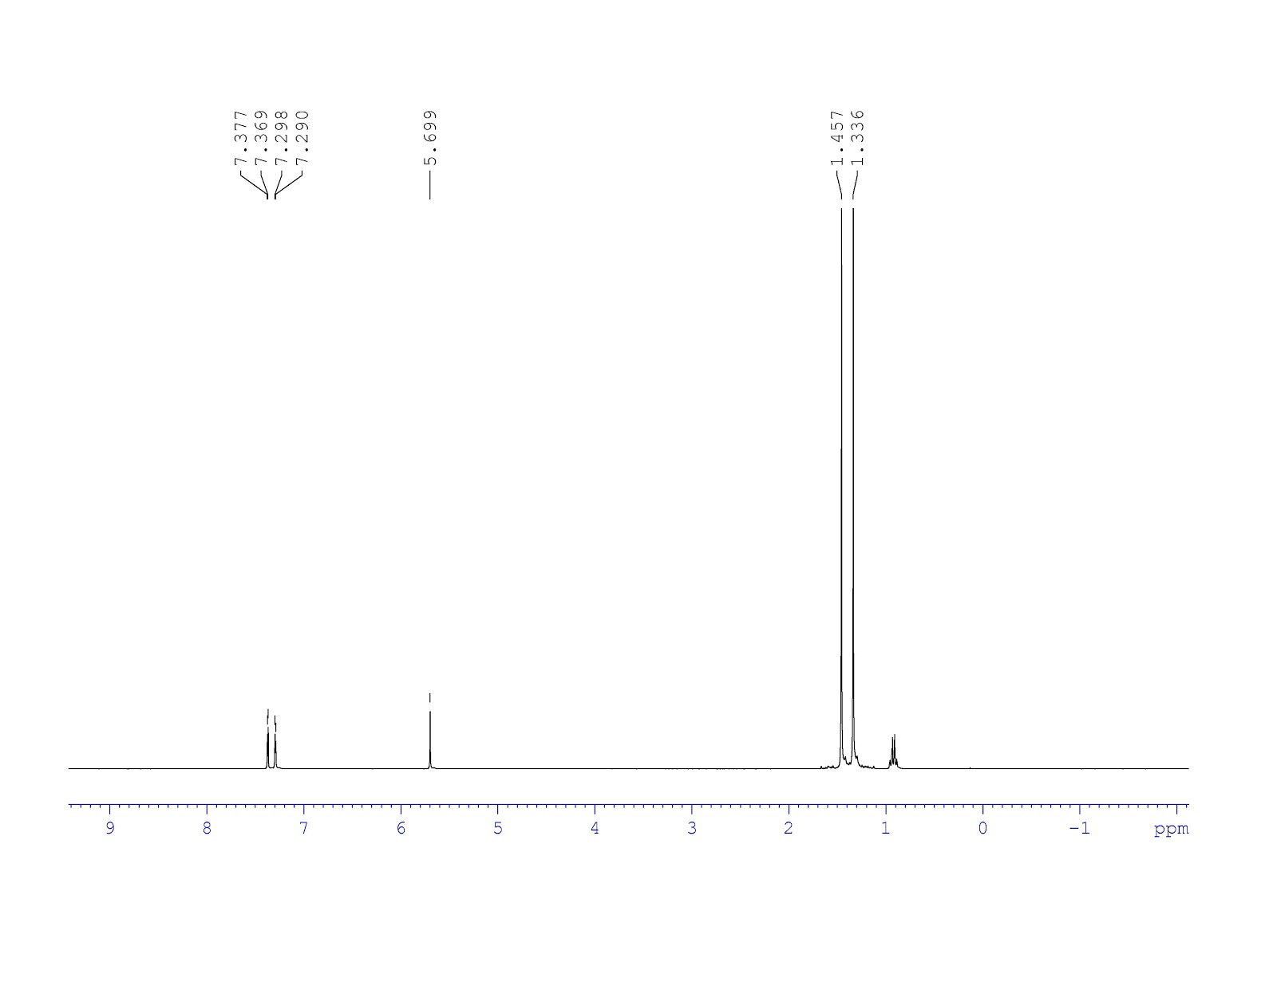

H5

H4

H3

H2

H1

1H NMR (300 MHz, CDCl3) δ: 1.34 (9H, s, H1); 1.46 (9H, s, H2); 5.69 (2H, s, H3); 7.29 (1H, s, H4); 7.38 (1H, s, H5)

1H NMR of 2,4-di-tert-butyl-6-(diphenylphosphanyl)phenol

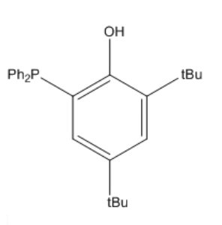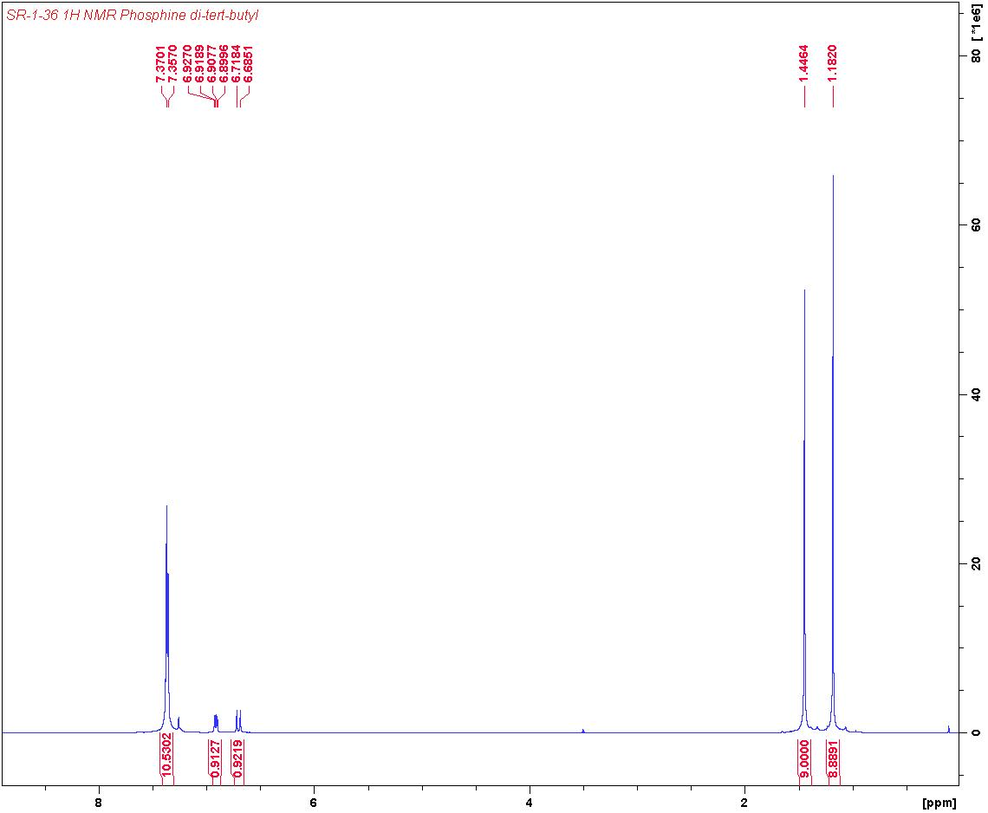

H5

H4

H3

H2

H1

1H NMR (300 MHz, CDCl3) δ: 1.18 (9H, s, H1); 1.45 (9H, s, H2); 6.70 (1H, d, H3); 6.91 (1H, d, H4); 7.38 (1H, m, H5)

31P NMR of 2,4-di-tert-butyl-6-(diphenylphosphanyl)phenol

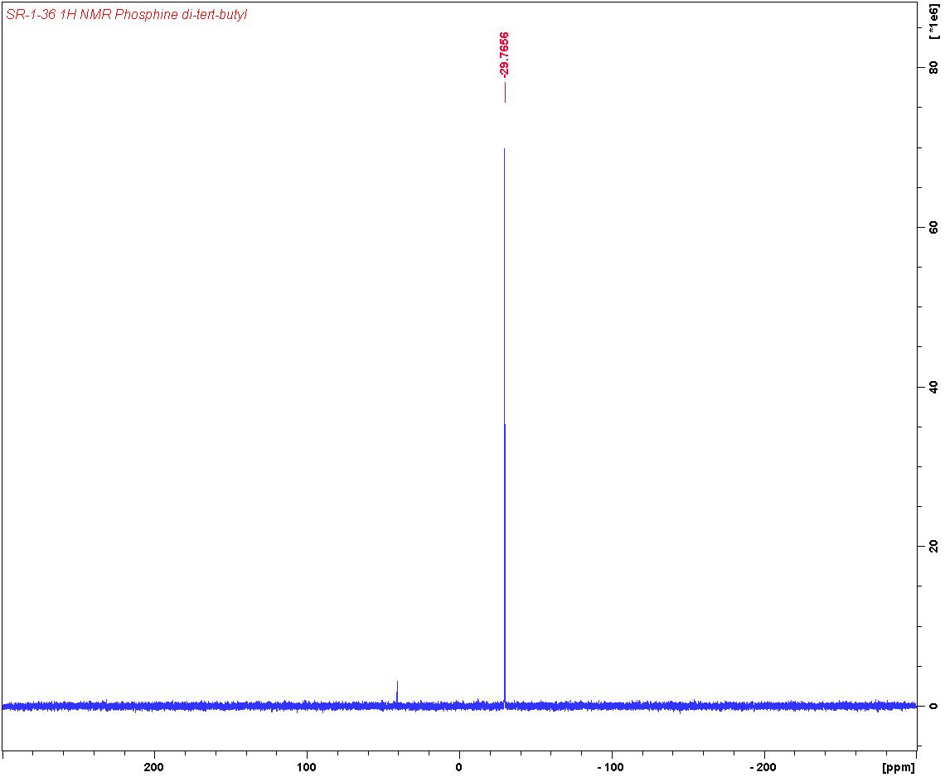

31P NMR (300 MHz, CDCl3) δ: -29.7

1H NMR of PhosfeNNN(di-tert-butyl)

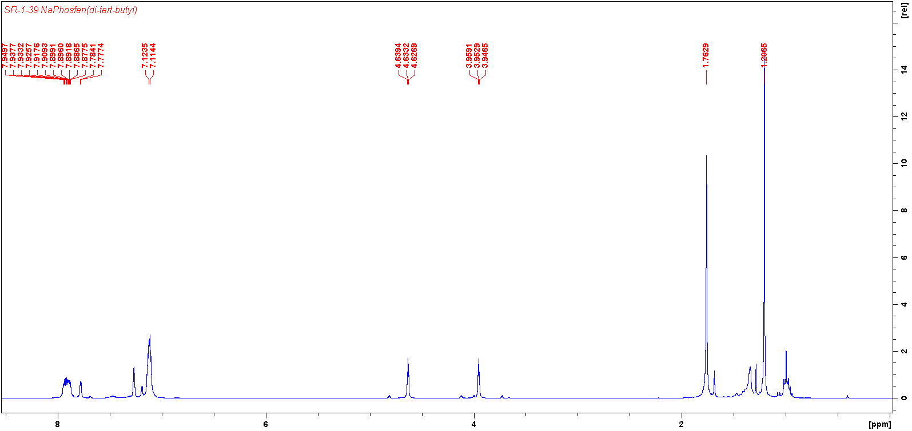

H5-H8

H3, H4

H2

H1

1H NMR (300 MHz, C6D6)

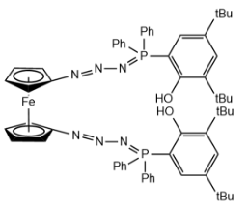

H7,8

H5

H2

H6

H4

H3

H1

31P NMR of PhosfeNNN(di-tert-butyl)

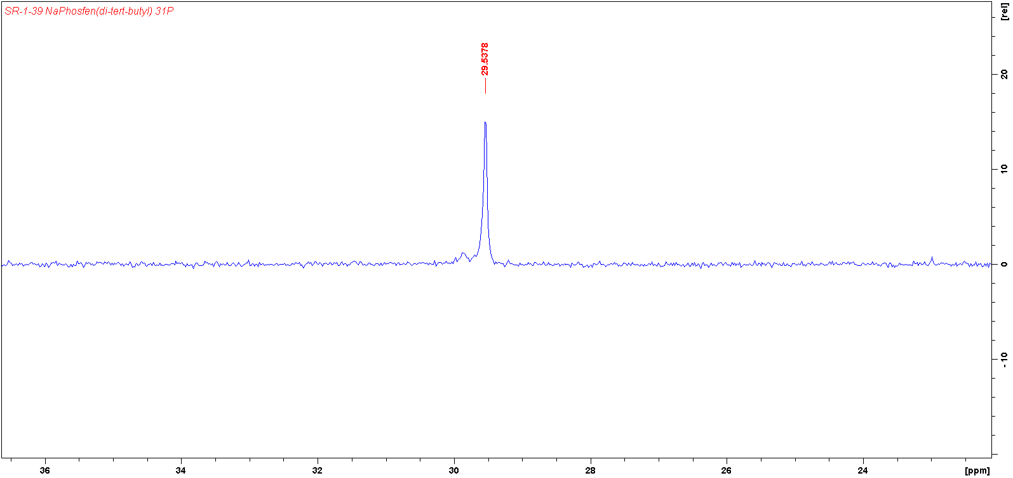

31P NMR (300 MHz, C6D6) δ: 29.5

1H NMR of H2phosfen(2,4-di-tert-butyl)

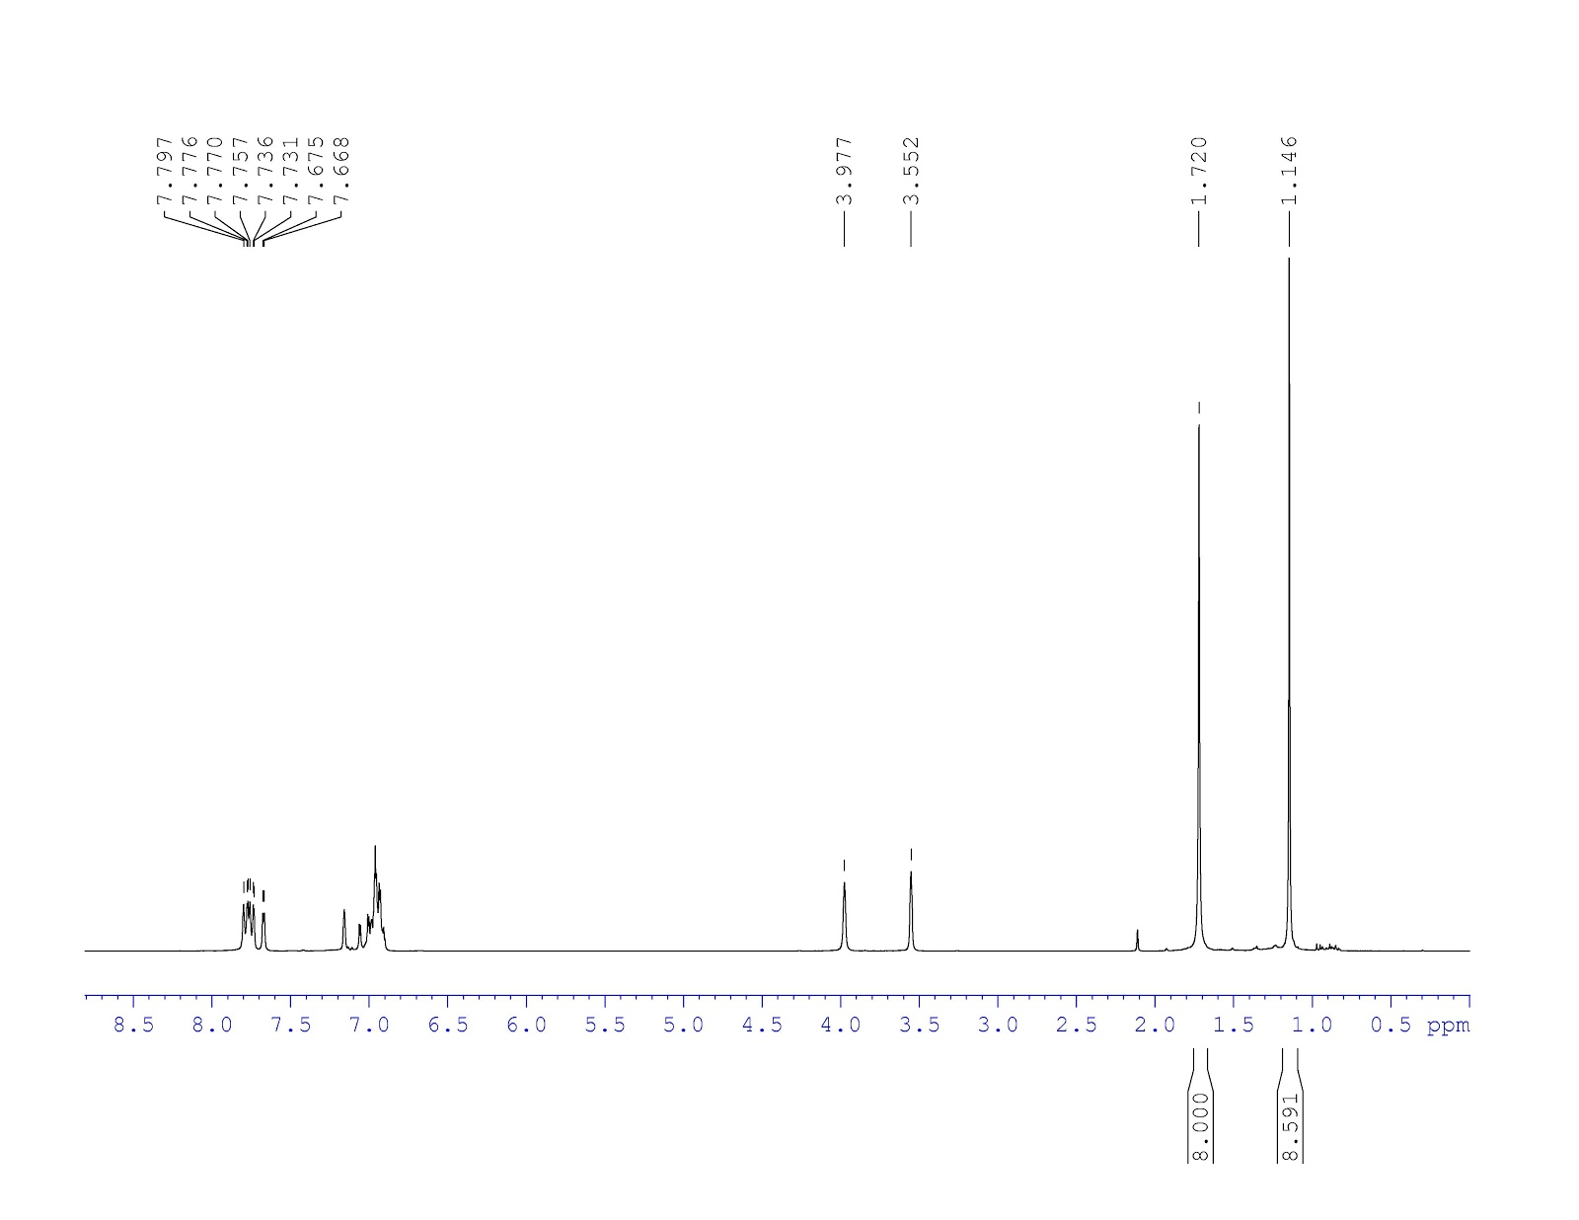

H5-8

H3, H4

H2

H1

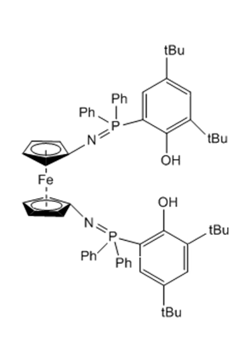1H NMR (300 MHz, C6D

H2

H8

H7

H6

H5

H4

H3

H1

31P NMR of H2phosfen(2,4-di-tert-butyl) 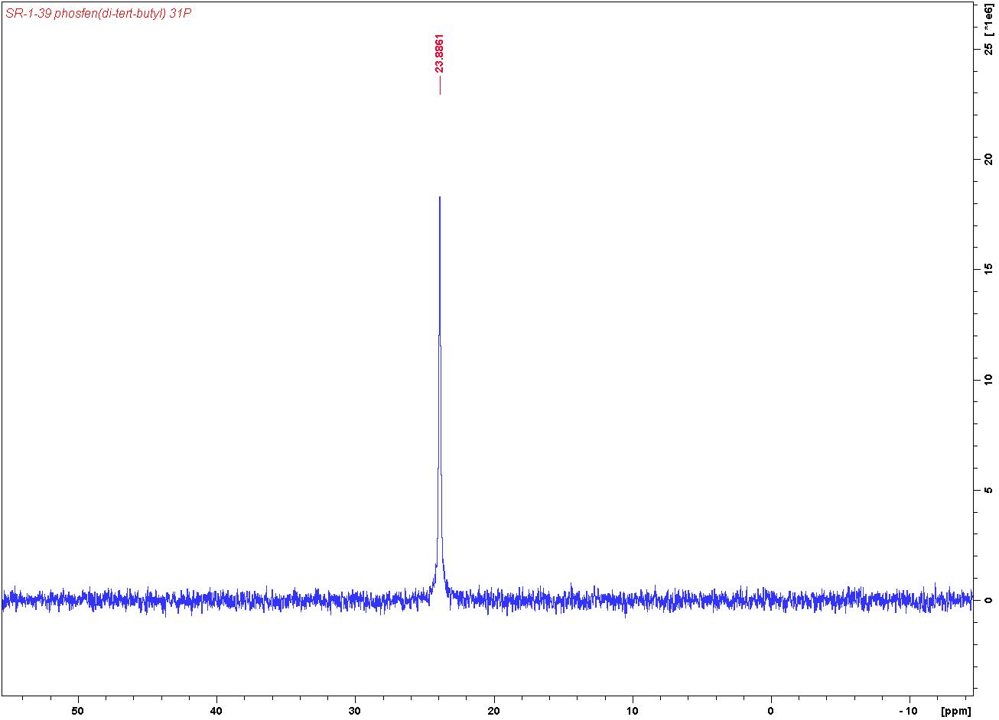

31P NMR (300 MHz, C6D6) δ: 23.9

1H NMR of YCl(phosfen(2,4-di-tBu))

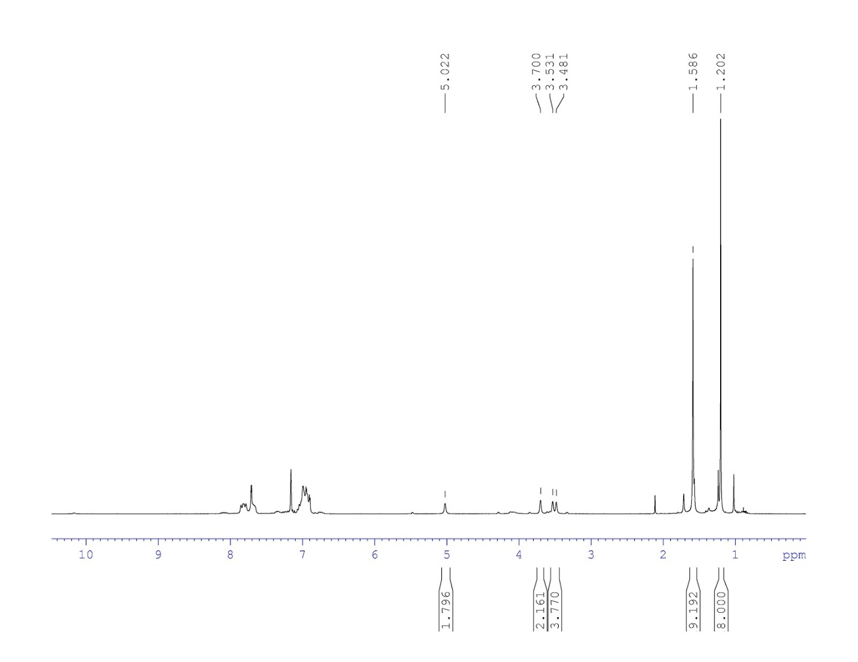

H5-8

H3, H4

H2

H1

1H NMR (300 MHz, C6D6)

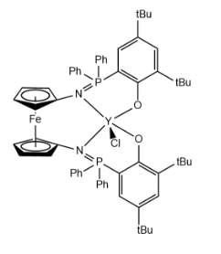

H6

H2

H8

H7

H5

H3

H4

H1

31P NMR of YCl(phosfen(2,4-di-tBu))

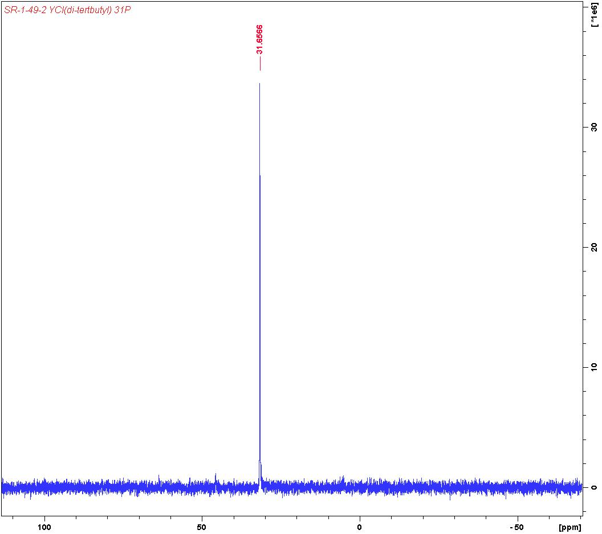

31P NMR (300 MHz, C6D6) δ: 31.7

1H NMR of InCl(phosfen(2,4-di-tBu))

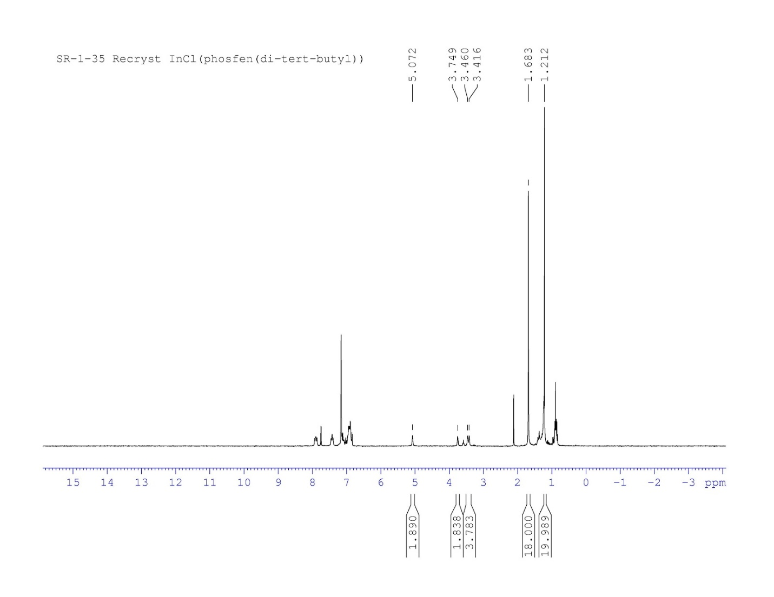

H3, H4

H5-8

H2

H1

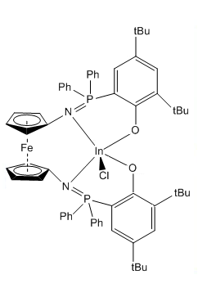1H NMR (300 MHz, C6D6)

H2

H7

H6

H8

H5

H4

H3

H1

31P NMR of InCl(phosfen(2,4-di-tBu))

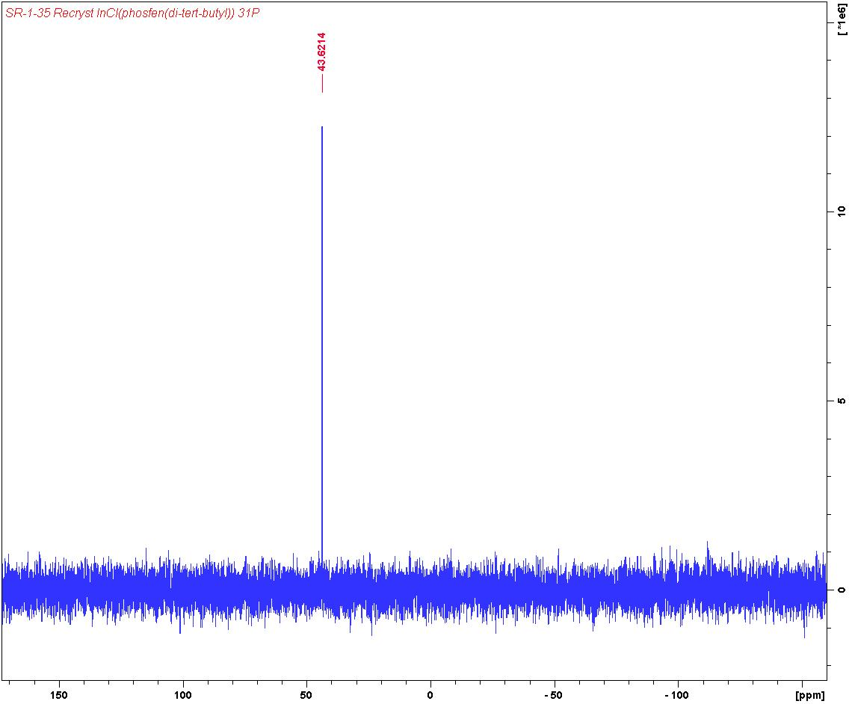

31P NMR (300 MHz, C6D6) δ: 31.7

1H NMR of YOtBu(phosfen(2,4-di-tBu))

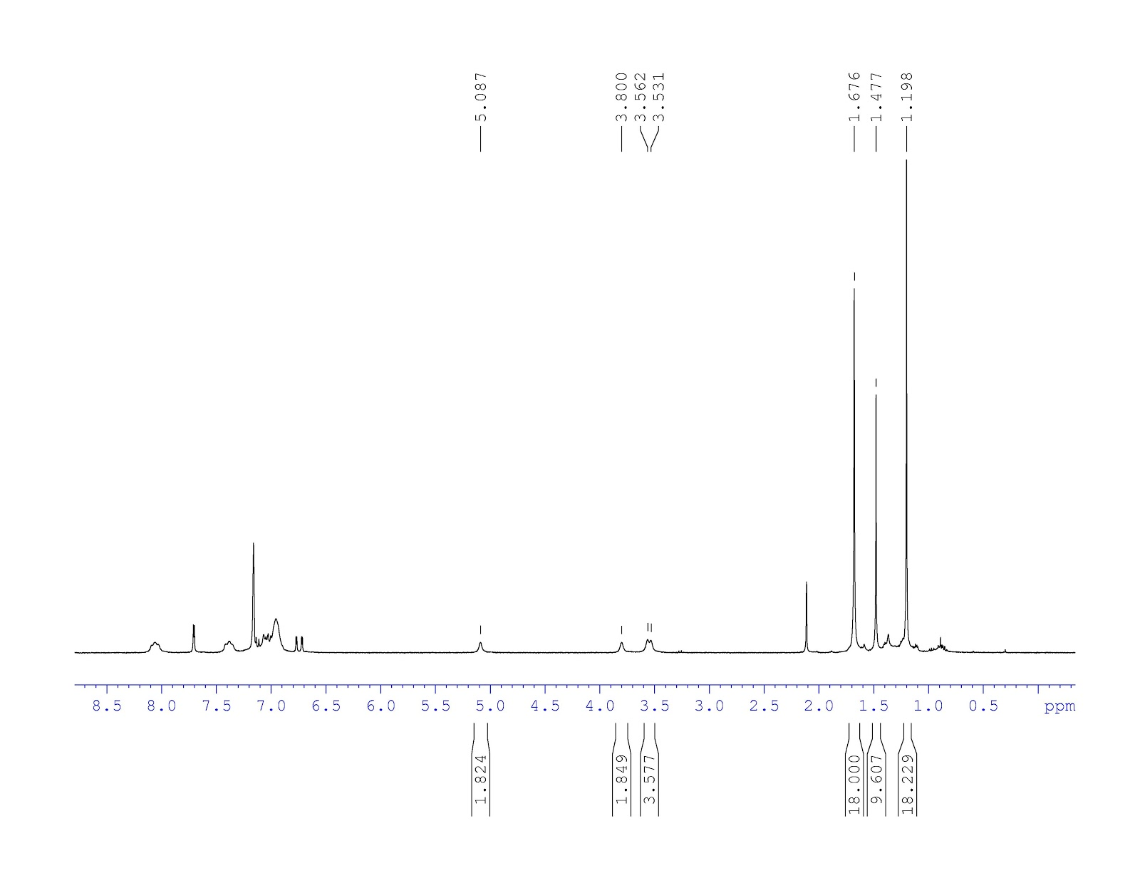

H5-8

H3, H4

H2

H9

H1

1H NMR (300 MHz, C6D6)

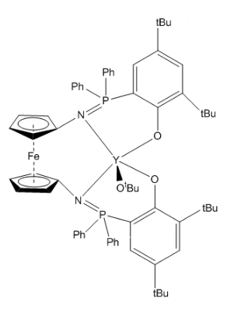

H2

H7

H6

H8

H5

H4

H3

H1

H9

31P NMR of YOtBu(phosfen(2,4-di-tBu))

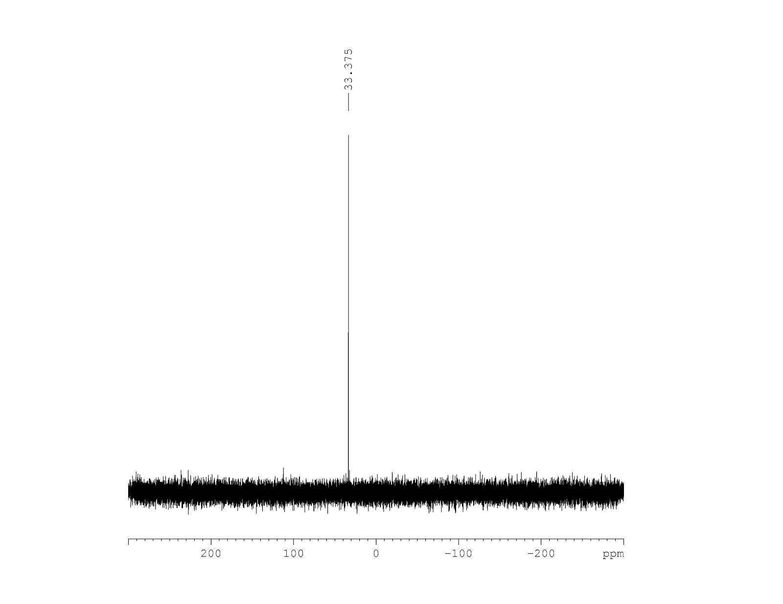

31P NMR (300 MHz, C6D6) δ: 31.7

1H NMR of oxidized YOtBu(phosfen(2,4-di-tBu))

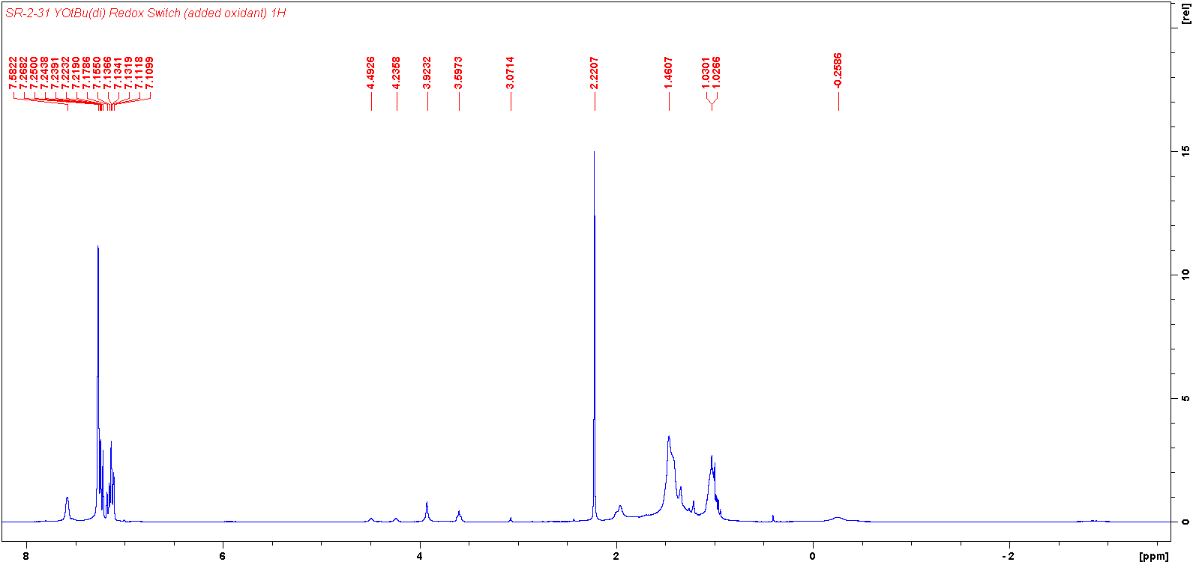

19F NMR of oxidized YOtBu(phosfen(2,4-di-tBu))

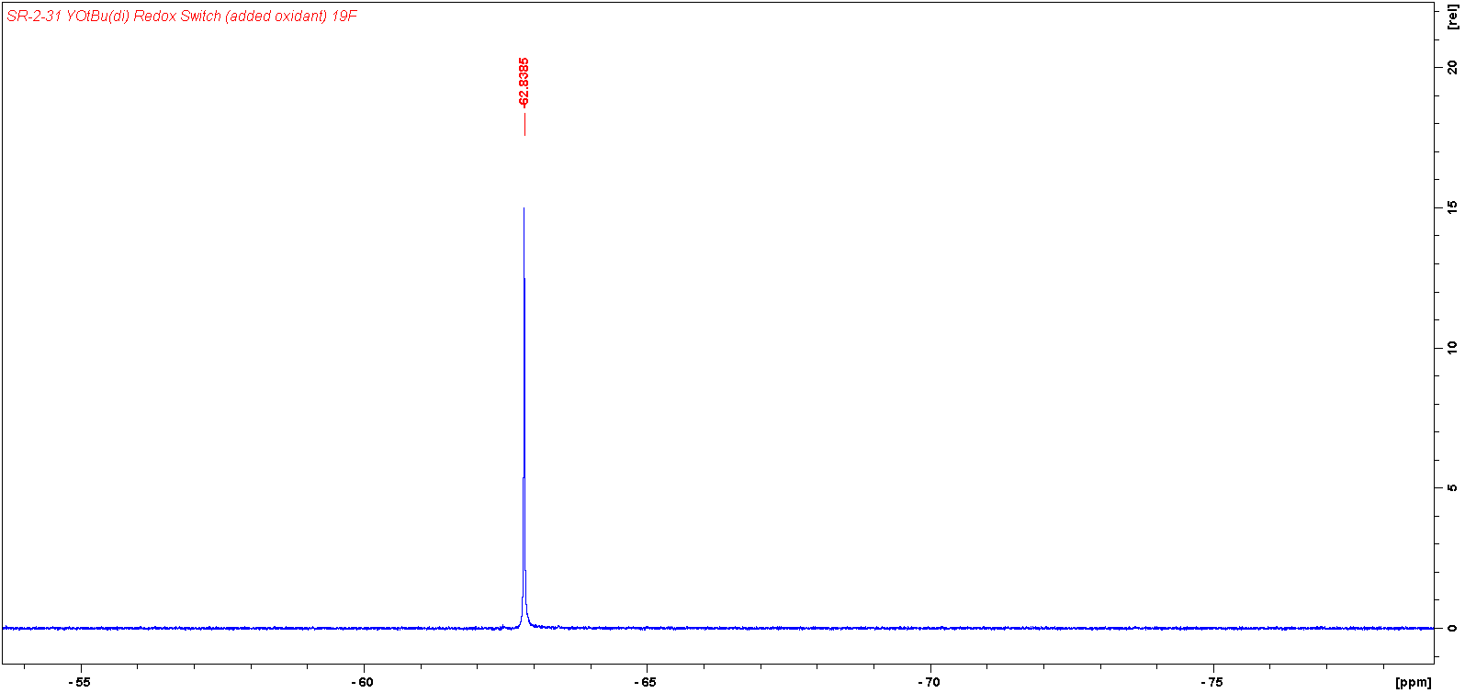

1H NMR 2-bromo-6-(tert-butyl)phenol

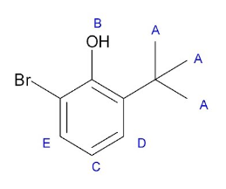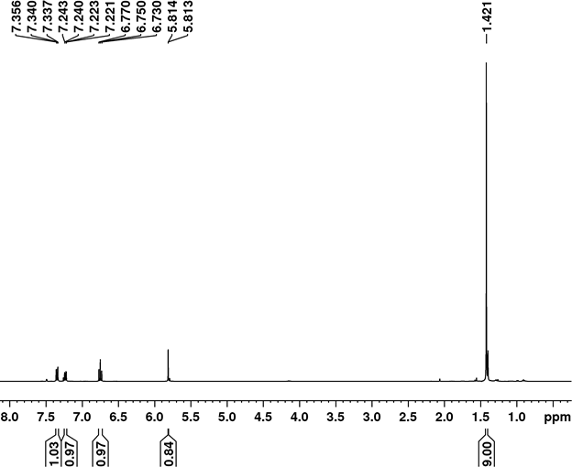

1H NMR (300 MHz, CDCl3) δ: 1.42 (9H, s, HA); 5.81 (1H, s, HB); 6.77 (1H, t, HC); 7.24 (1H, d, HD); 7.36 (1H, d, HE)

1H NMR of 2-(tert-butyl)-6-(diphenylphosphino)phenol

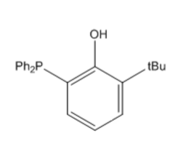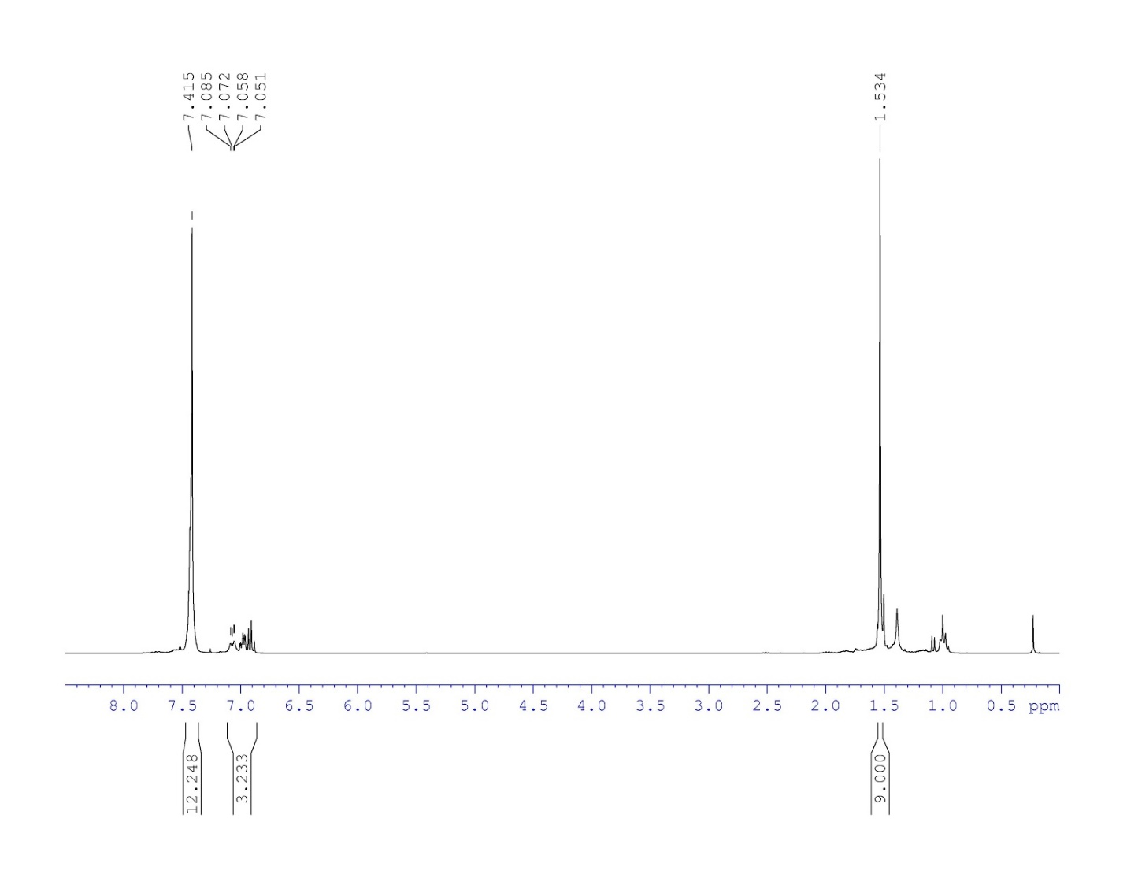

H5

H4

H3

H2

H1

1H NMR (300 MHz, CDCl3) δ: 1.53 (9H, s, H1); ~6.8-7.3 (1H, d,t,d, H2,3,4); 7.42 (10H, t, H5)

31P NMR of 2-(tert-butyl)-6-(diphenylphosphino)phenol

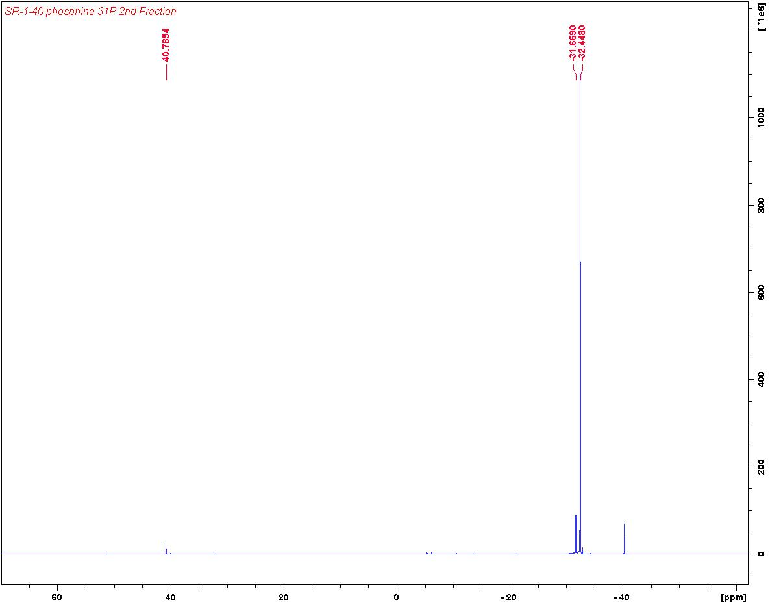

31P NMR (300 MHz, CDCl3) δ: -32.4

1H NMR PhosfeNNN(mono-tert-butyl)

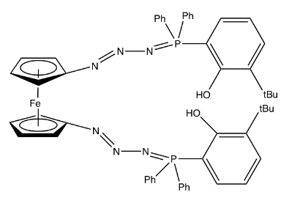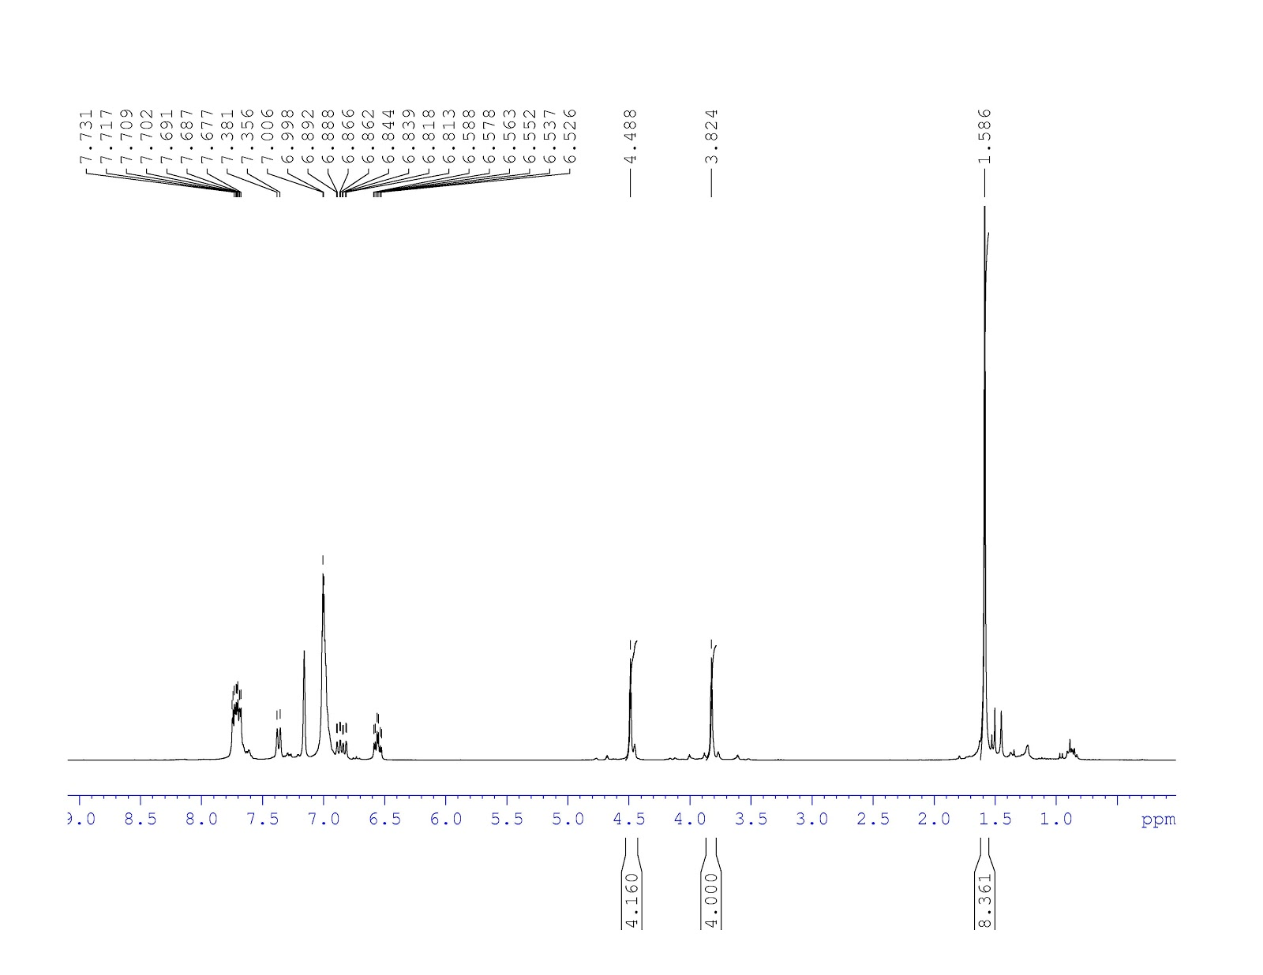

H7

H6

H5

H2

H4

H3

H2

H1

1H NMR (300 MHz, C6D6) δ: 1.59 (9H, s, H1); 4.00 (4H, H2); 4.49 (4H, H3); 6.54 (1H, t, H4); 6.86 (1H, d, H6); 6.99 (5H, H6); 7.36 (1H, d, H5); ~7.70 (5H, H7)

31P NMR PhosfeNNN(mono-tert-butyl)

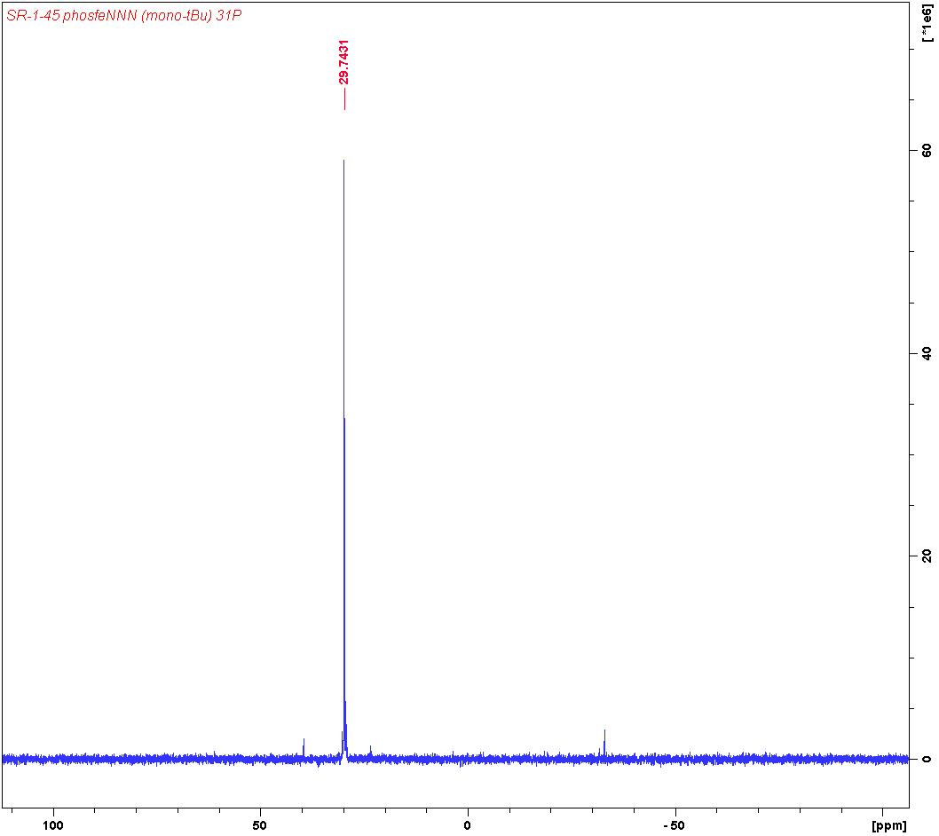

31P NMR (300 MHz, C6D6) δ: 29.7

1H NMR of H2phosfen(mono-tert-butyl)

H4

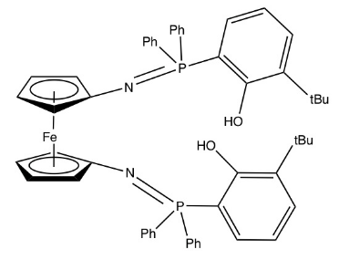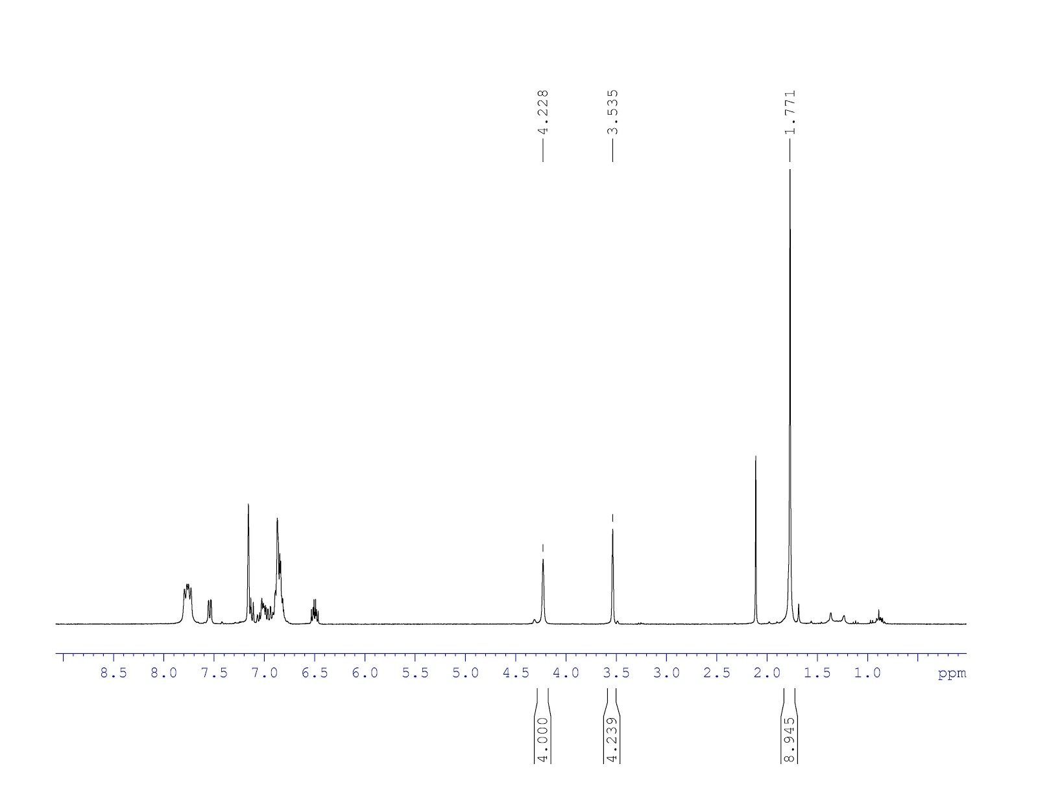

H8

H7

H6

H5

H2

H3

H1

1H NMR (300 MHz, C6D6) δ: 1.77 (9H, s, H1); 3.54 (4H, H2); 4.23 (4H, H3); ~6.49 (1H, t, H4); ~7.0 (5H, H6); ~6.89 (1H, H5); ~7.54 (1H, d, H7); ~7.79 (5H, H8)

31P NMR of H2phosfen(mono-tert-butyl)

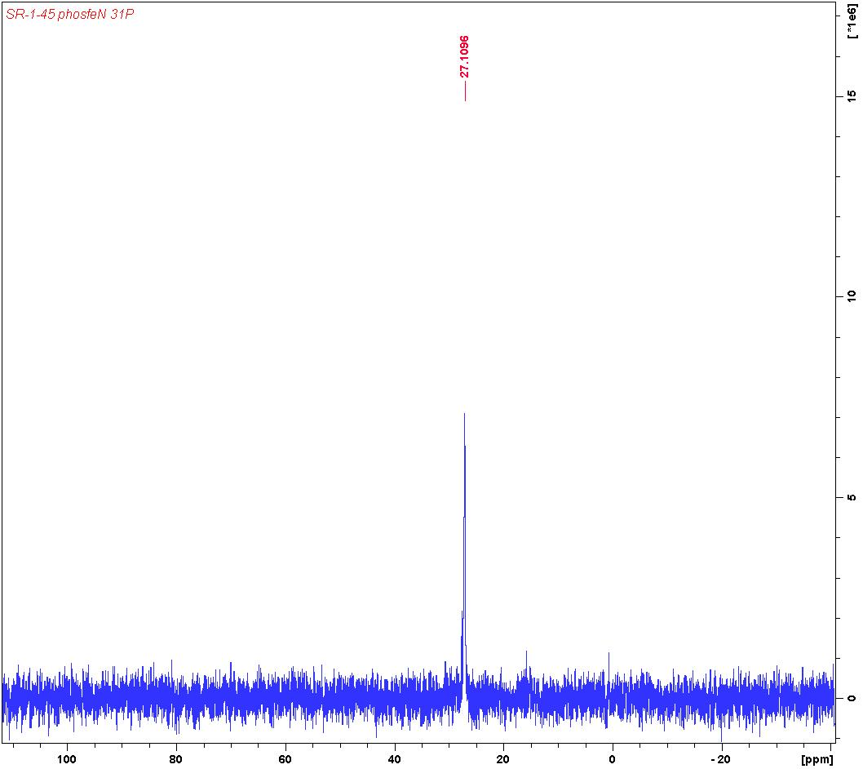

31P NMR (300 MHz, C6D6) δ: 29.7

1H NMR of YCl(phosfen(2-tBu))

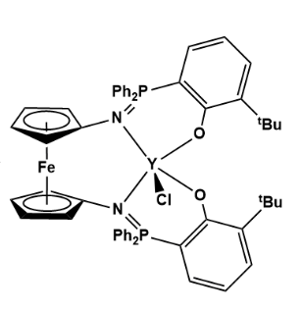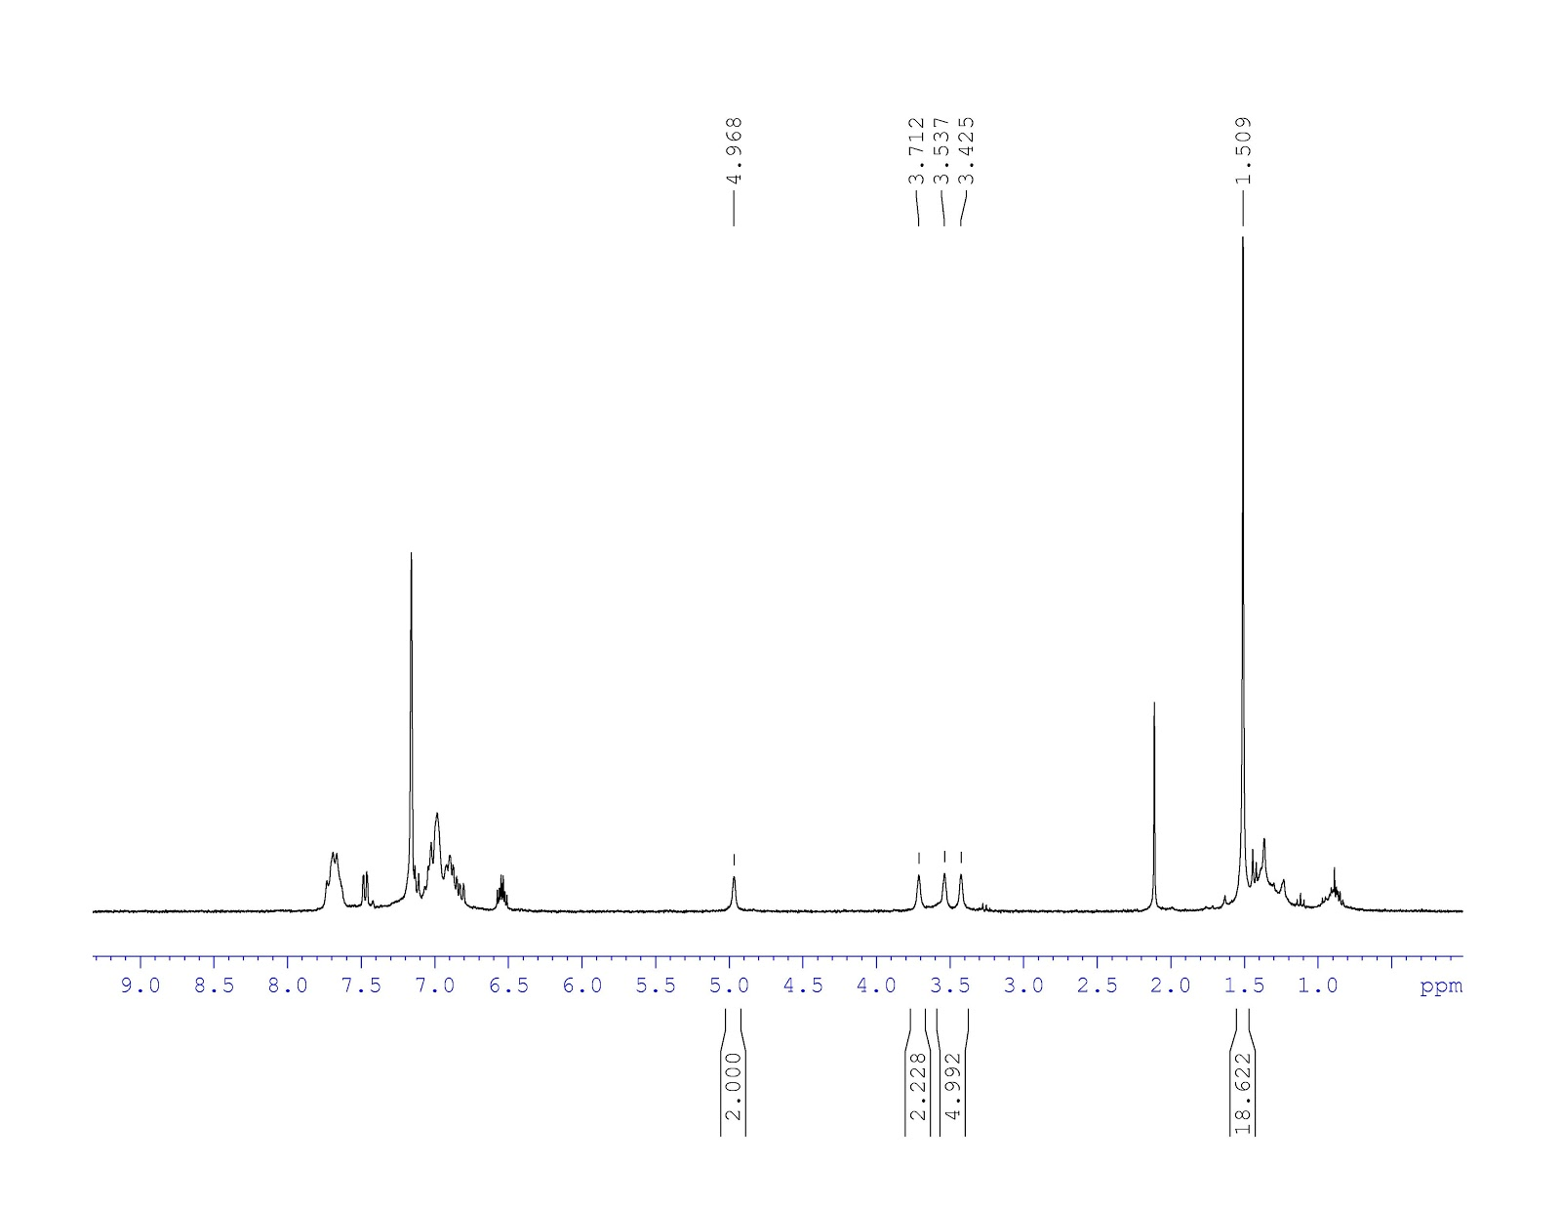

H8

H4

H7,H5

H4

H2,H3

H1

H1

H7-8

H2

H6

H5

H4

H3

31P NMR of YCl(phosfen(2-tBu))

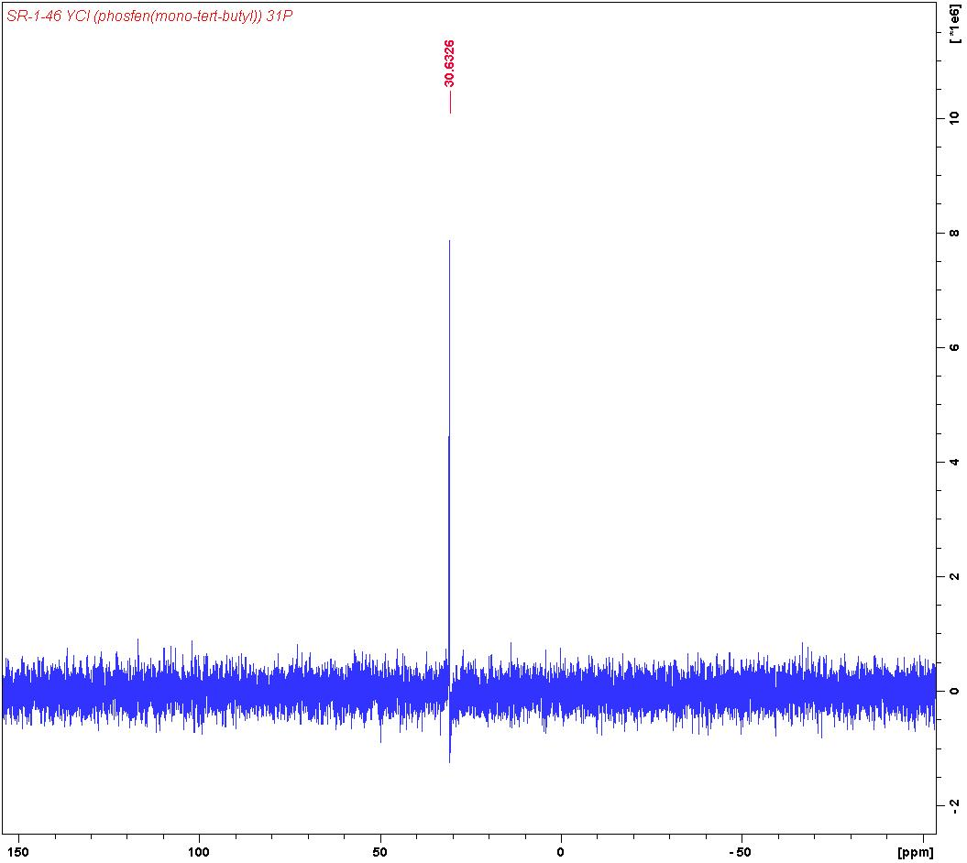

31P NMR (300 MHz, C6D6) δ: 30.6

1H NMR of 1-Y(OtBu)phosfen(2-tBu)

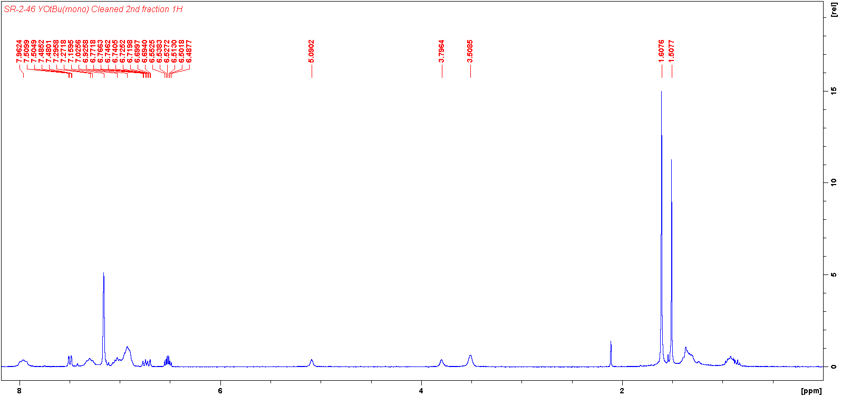

H8, H9

H7

H6

H5

H3, H4

H2

H1

1H NMR (300 MHz, C6D6)

H8

H5

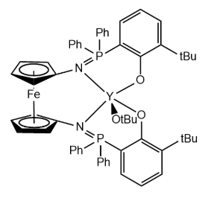

H9

H7

H6

H4

H3

H1

H2

1H NMR of 1-Y(OtBu)phosfen(2-tBu)

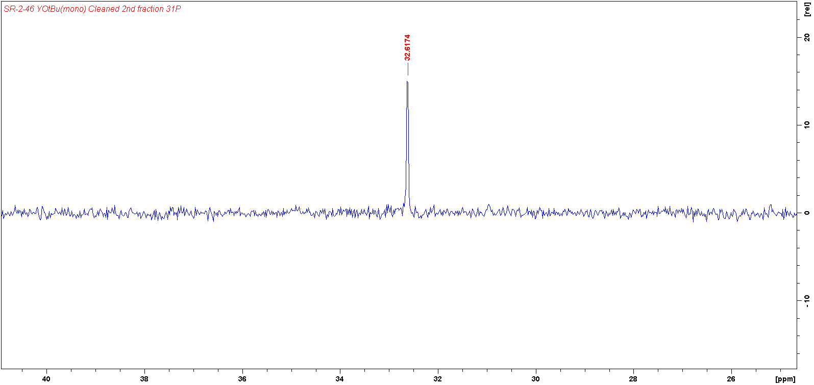

31P NMR (300 MHz, C6D6) δ: 30.6

**Y(OtBu)phosfen(di-tert-butyl) Polymerization 1H NMRs**

***Lactide***

2 hours

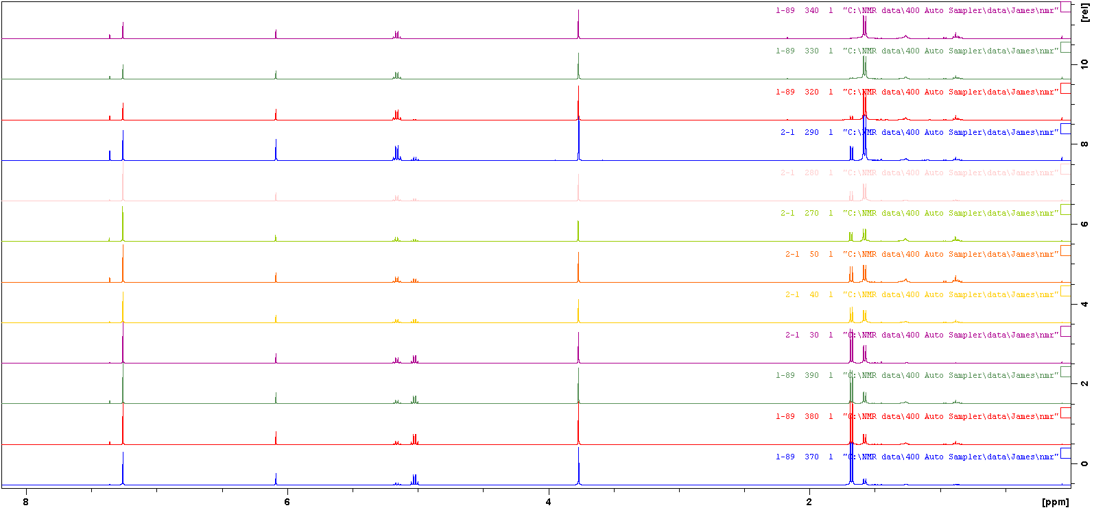

1 hour 30 min

1 hour

45 min

35 min

30 min

25 min

20 min

14 min

11 min

3 min

9 min

1H NMR (400 MHz, CDCl3). (**M**:monomer; **S**:standard,trimethoxybenzene; **P**:polymer). (time:conversion%): 3mins:21%; 9mins:31%; 11mins:39%; 14mins: 50%; 20mins:58%; 25mins:67%; 30mins:71%; 35mins:78%; 45mins:85%; 1hour:94%; 1hour30mins:97%; 2hours:99%.

***Lactide (oxidized)***

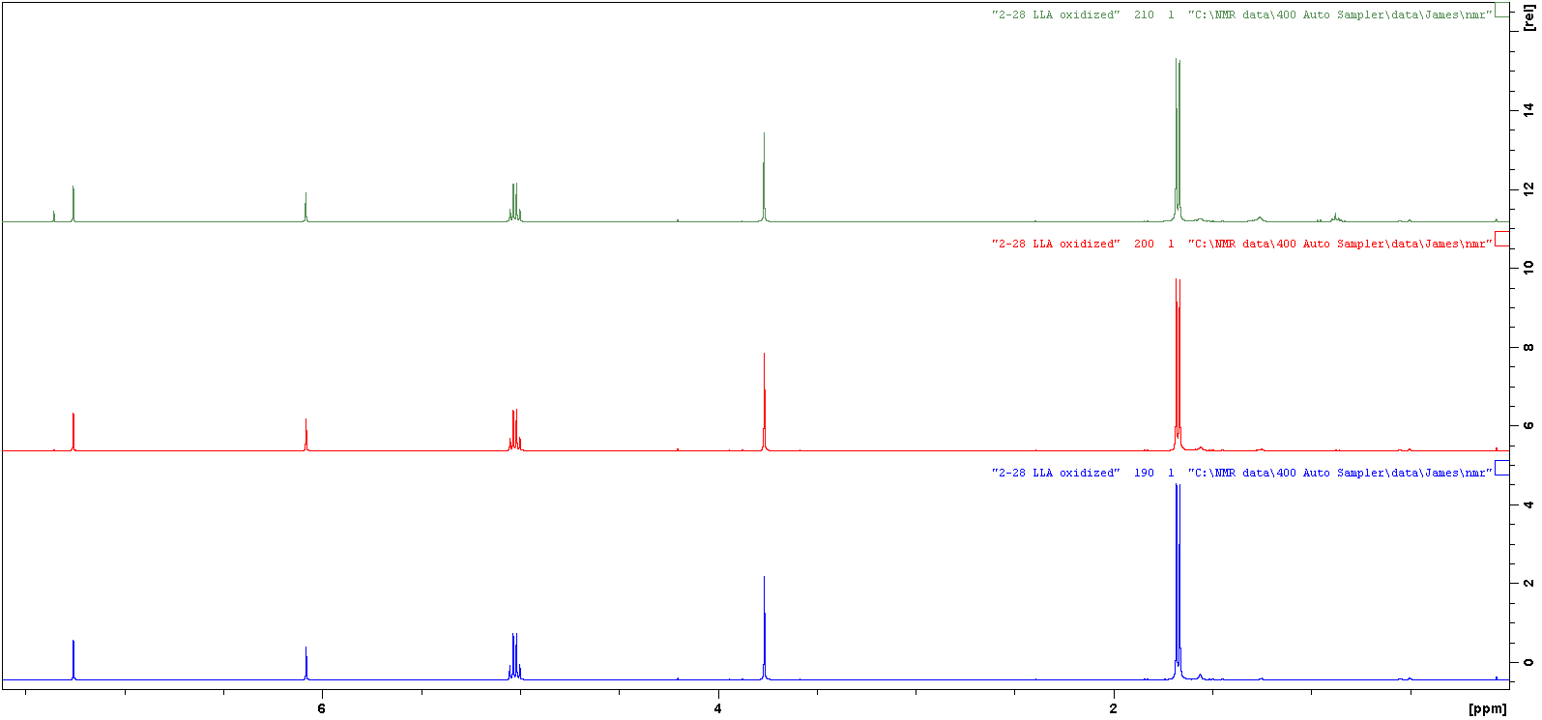

**M**

**M**

**S**

**S**

1 hour 30 mins

1 hour

30 mins

1H NMR (400 MHz, CDCl3). (**M**:monomer; **S**:standard,trimethoxybenzene; **P**:polymer). (time:conversion%): 30mins:0%; 1hour:0%; 1hour30mins:0%.

***Epsilon Caprolactone***

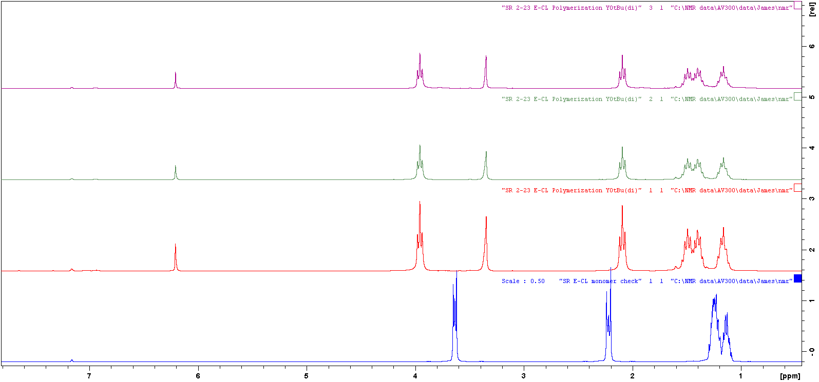

**S**

**P**

**P**

**P**

**S**

1 hour

5 mins

30 mins

monomer

1H NMR (400 MHz, CDCl3). (**M**:monomer; **S**:standard,trimethoxybenzene; **P**:polymer). (time:conversion%): 5mins:100%.

***Epsilon Caprolactone (oxidized)***

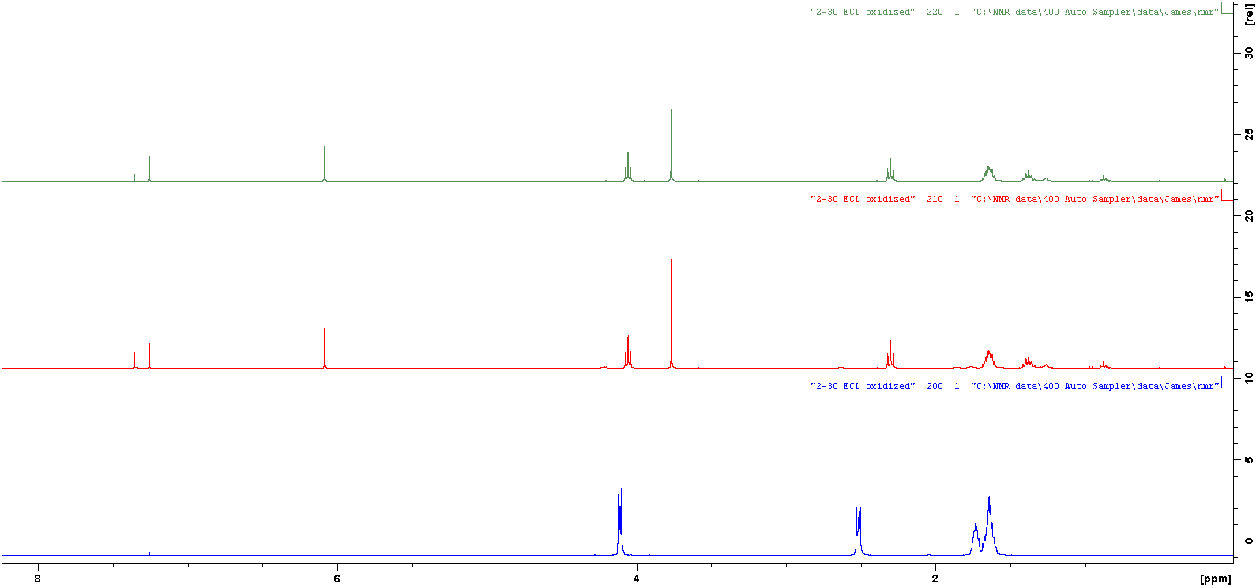

**P**

**P**

**P**

**S**

**S**

30 mins

10 mins

monomer

1H NMR (400 MHz, CDCl3). (**M**:monomer; **S**:standard,trimethoxybenzene; **P**:polymer). (time:conversion%):5mins:100%

***Cyclohexene Oxide oxidized***

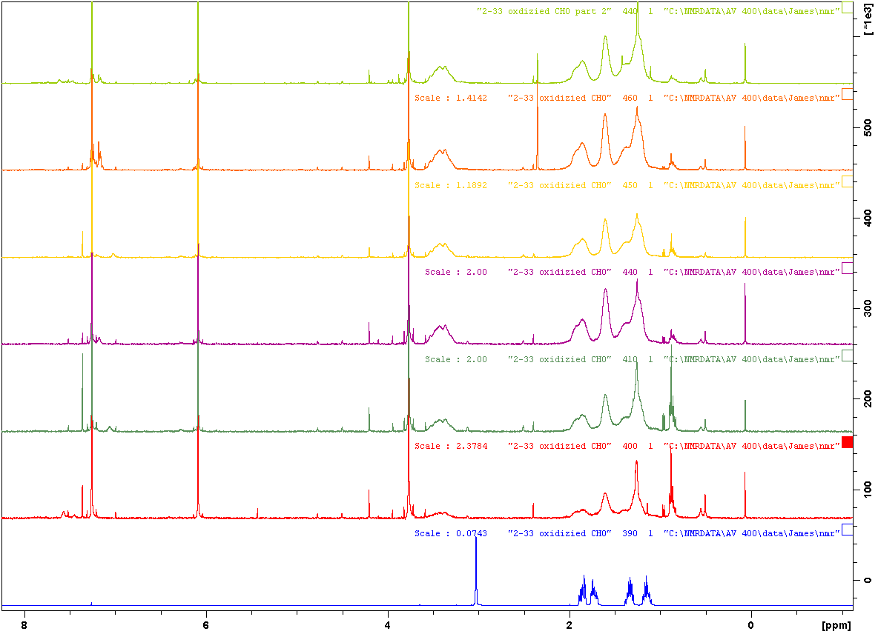

**P**

**S**

**S**

3 hour

1 hour

min

10mins

30 mins

40 mins

2 mins

monomer

1H NMR (400 MHz, CDCl3). (**M**:monomer; **S**:standard,trimethoxybenzene; **P**:polymer). (time:conversion%): 1hour:100%.

***Trimethylene Carbonate***

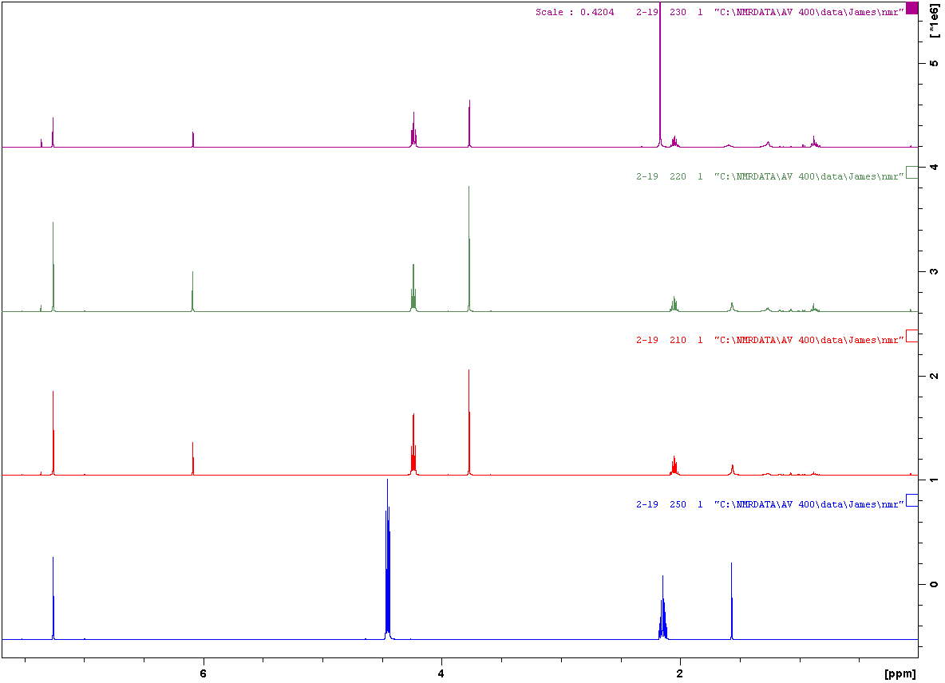

**M**

**M**

**P**

**P**

**S**

**S**

10 mins

6 mins

5 mins

monomer

1H NMR (400 MHz, CDCl3). (**M**:monomer; **S**:standard,trimethoxybenzene; **P**:polymer). (time:conversion%): 3mins:100%.

***Trimethylene Carbonate (-78°C)***

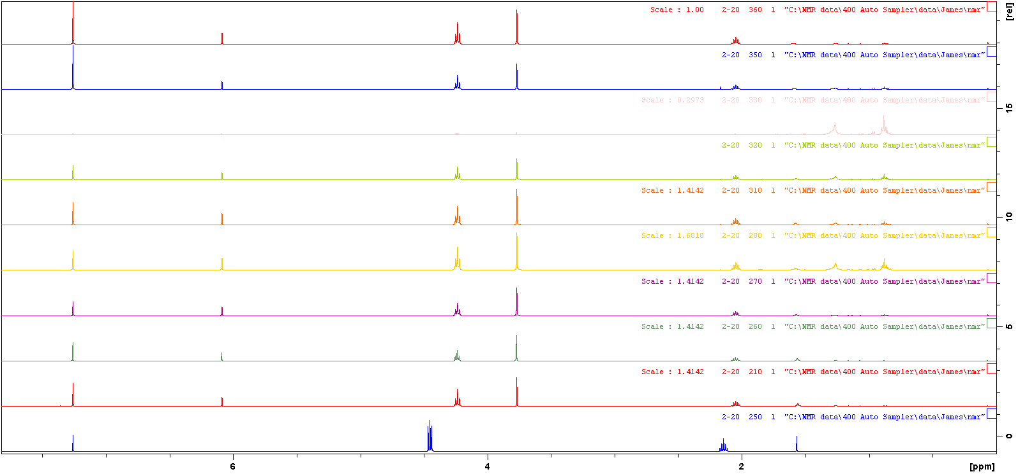

**M**

**M**

**P**

**P**

**S**

**S**

3 hr

1 hr 30 min

1 hr

40 min

30 min

20 min

10 min

7 min

5 min

monomer

1H NMR (400 MHz, CDCl3). (**M**:monomer; **S**:standard,trimethoxybenzene; **P**:polymer). (time:conversion%): 5mins:100%.

***Styrene Oxide***

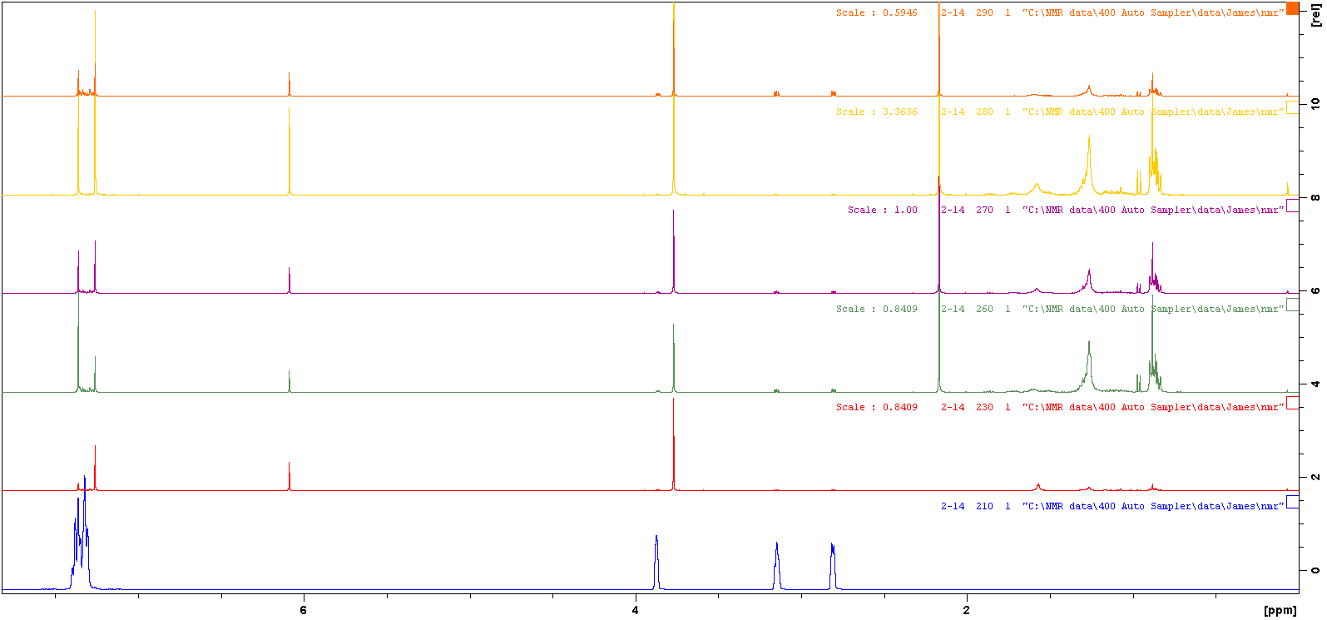

**M**

**M**

**M**

**M**

**S**

**S**

5 hrs 15 mins

1hr 15 mins

3 hrs 15mins

>24 hrs

15 mins

monomer

1H NMR (400 MHz, CDCl3). (**M**:monomer; **S**:standard,trimethoxybenzene; **P**:polymer). (time:conversion%): 15mins:0%; 24hours:0%

11 min

9 min

***Styrene Oxide (oxidized)***

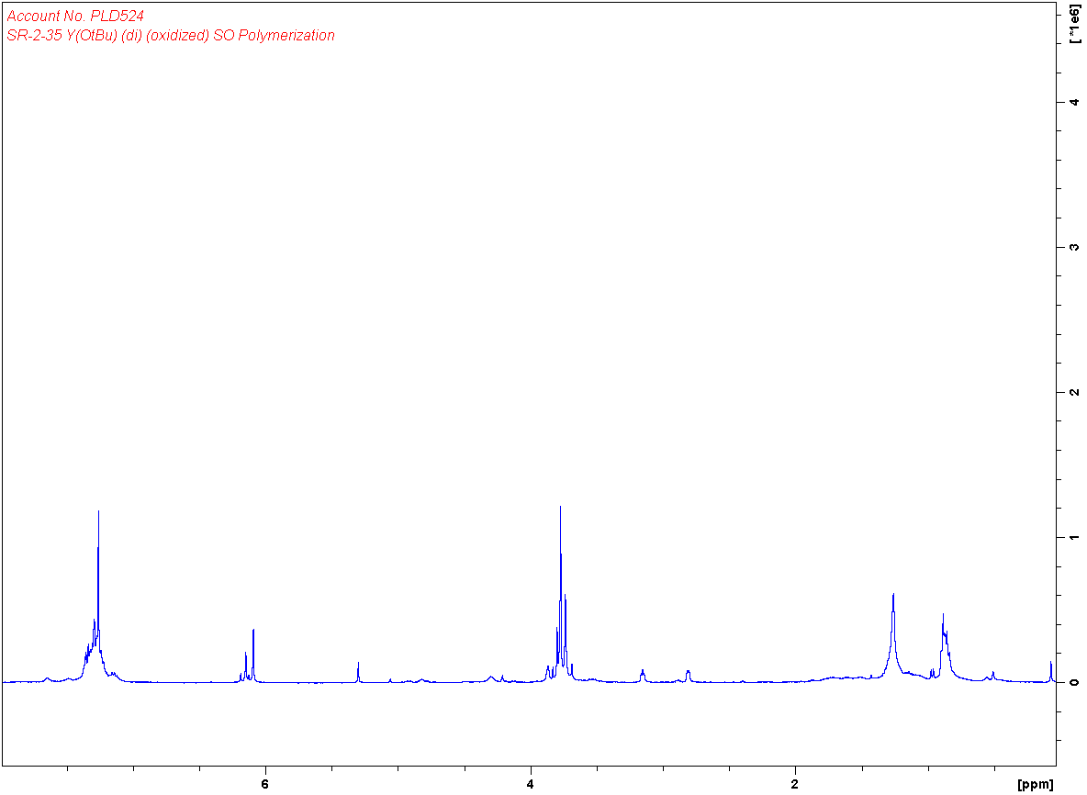

**M**

**M**

3 hours

1H NMR (400 MHz, CDCl3). (**M**:monomer; **S**:standard,trimethoxybenzene; **P**:polymer). (time:conversion%): 3hours:0%

***Propylene Oxide***

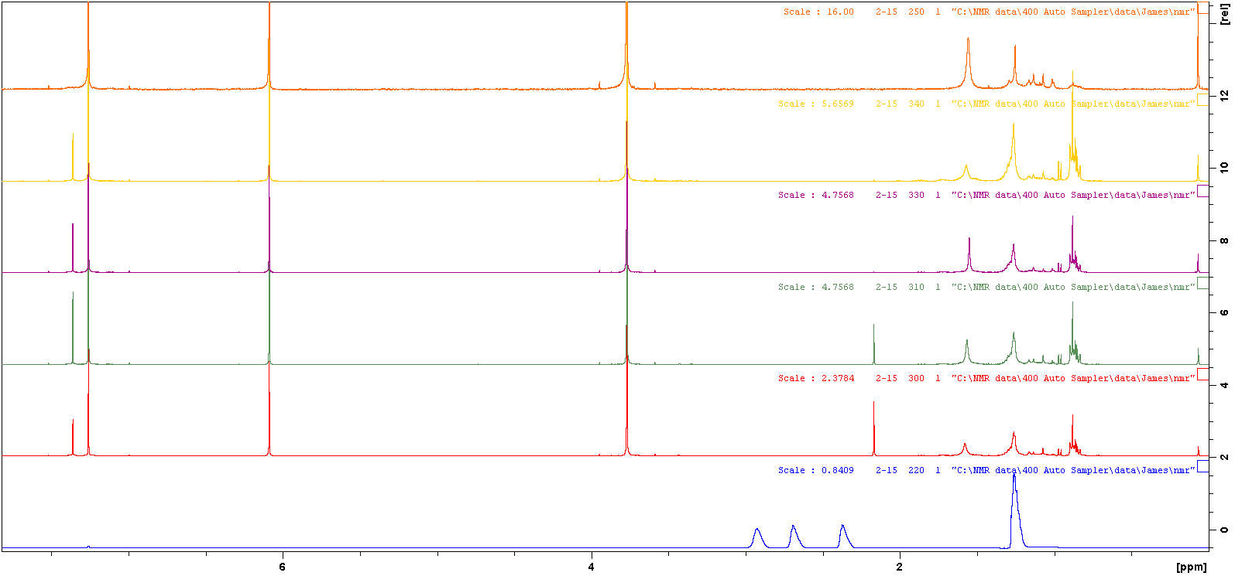

**S**

**S**

>24hr

5hr 15 min

3hr 15 min

1 hr 15 min

15 min

monomer

1H NMR (400 MHz, CDCl3). (**M**:monomer; **S**:standard,trimethoxybenzene; **P**:polymer). (time:conversion%): 24hours:0%

***Propylene Oxide (oxidized)***

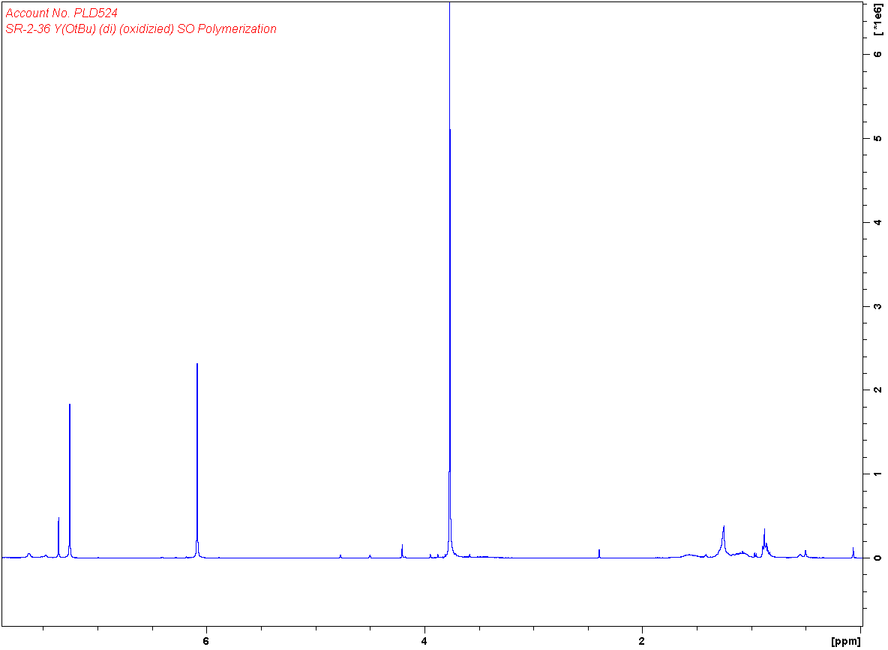

**S**

**S**

3 hours

1H NMR (400 MHz, CDCl3). (**M**:monomer; **S**:standard,trimethoxybenzene; **P**:polymer). (time:conversion%): 24hours:0%

***Beta-Butyrolactone***

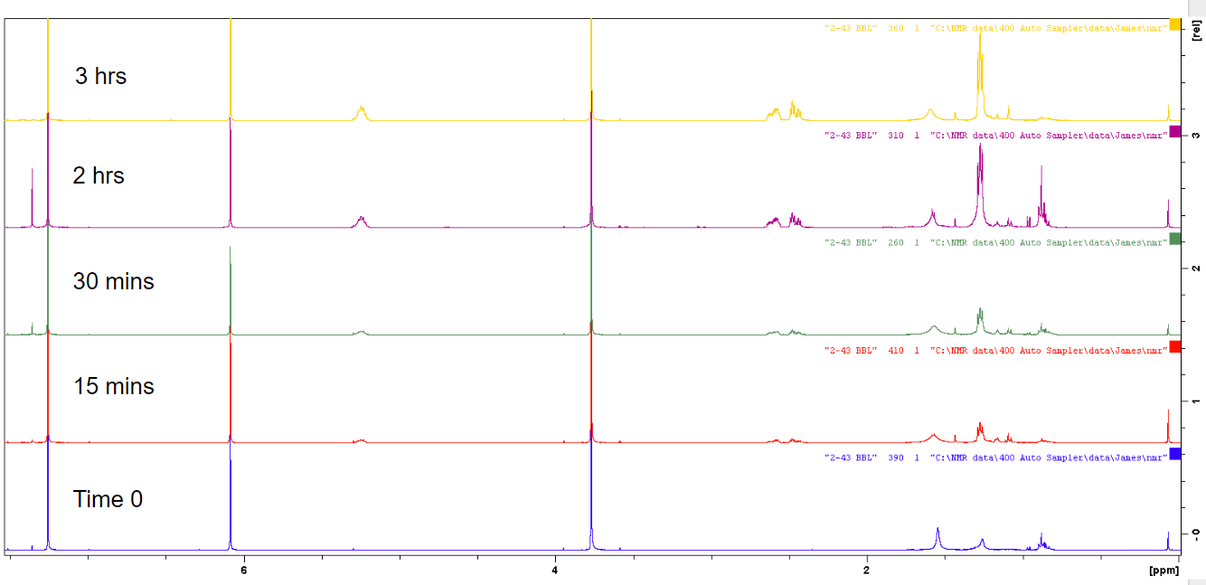

**P**

**P**

**P**

**S**

**S**

1H NMR (400 MHz, CDCl3). (**M**:monomer; **S**:standard,trimethoxybenzene; **P**:polymer). (time:conversion%): 2hours:100%

***Beta-Butyrolactone (oxidized)***

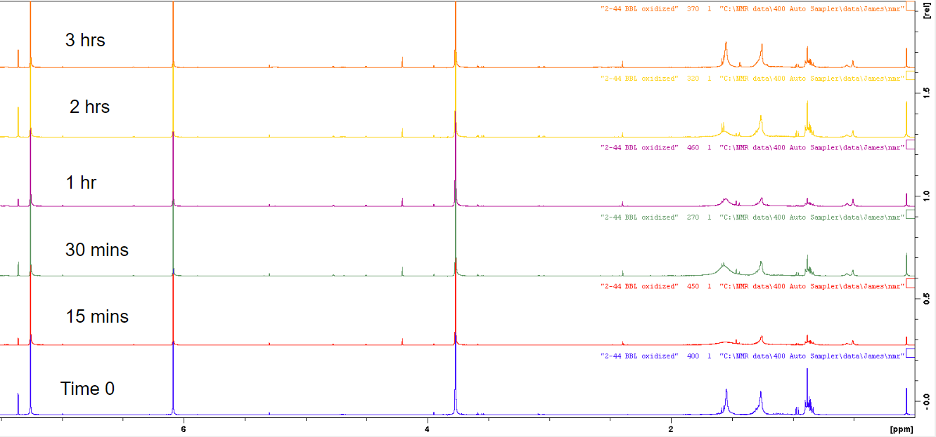

**M**

**S**

**S**

1H NMR (400 MHz, CDCl3). (**M**:monomer; **S**:standard,trimethoxybenzene; **P**:polymer). (time:conversion%): 3hours:0%

**Y(OtBu)phosfen(mono-tert-butyl) Polymerization 1H NMRs**

***Lactide***

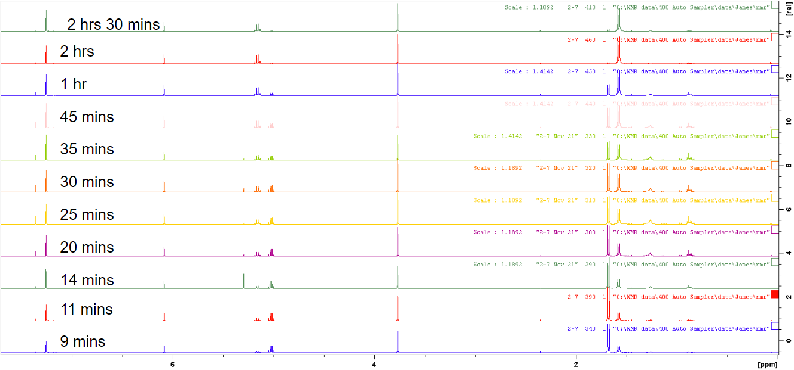

**P**

**M**

**M**

**P**

**S**

**S**

1H NMR (400 MHz, CDCl3). (**M**:monomer; **S**:standard,trimethoxybenzene; **P**:polymer). (time:conversion%): 9mins:25%; 11mins:32%; 14mins: 35%; 20mins:44%; 25mins:50%; 30mins:54%; 35mins:60%; 45mins:68%; 1hour:81%; 2hours:95%; 2hours30mins:98%

***Lactide (oxidized)***

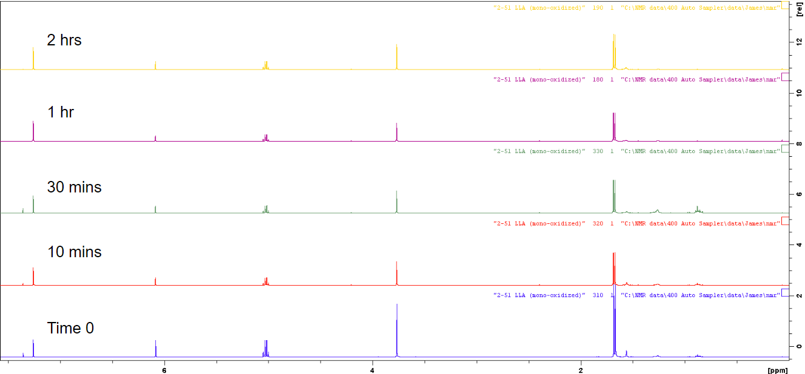

**M**

**S**

**M**

**S**

1H NMR (400 MHz, CDCl3). (**M**:monomer; **S**:standard,trimethoxybenzene; **P**:polymer). (time:conversion%): 2hrs:0%

***Epsilon Caprolactone***

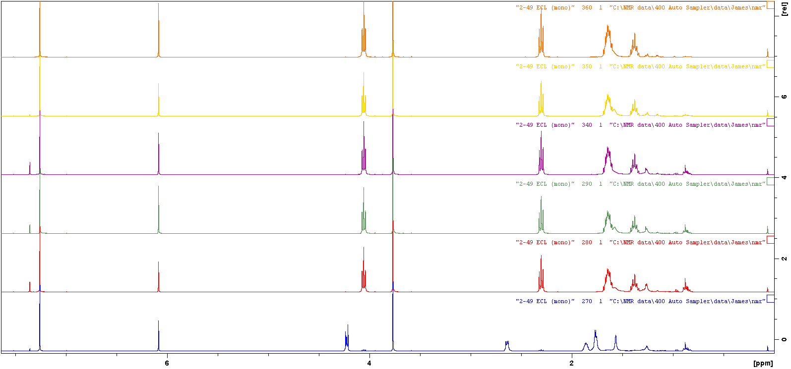

**M**

**M**

**M**

**P**

**P**

v

**P**

**S**

**P**

**S**

2 hrs

1 hr

30 mins

15 mins

5 mins

time 0

1H NMR (400 MHz, CDCl3). (**M**:monomer; **S**:standard,trimethoxybenzene; **P**:polymer). (time:conversion%): 5mins:100%

***Epsilon Caprolactone (oxidized)***

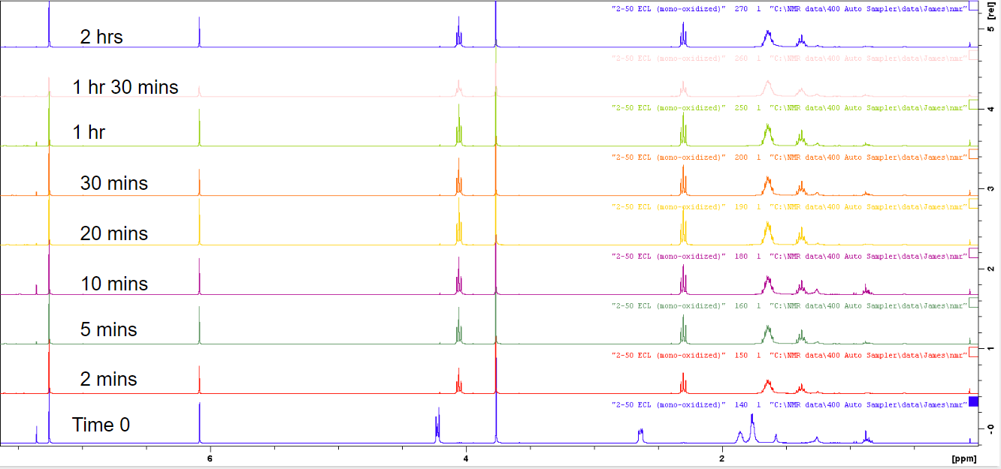

**M**

**M**

**M**

**P**

**P**

**P**

**S**

**P**

**S**

1H NMR (400 MHz, CDCl3). (**M**:monomer; **S**:standard,trimethoxybenzene; **P**:polymer). (time:conversion%): 5mins:100%

***Cyclohexene Oxide*** 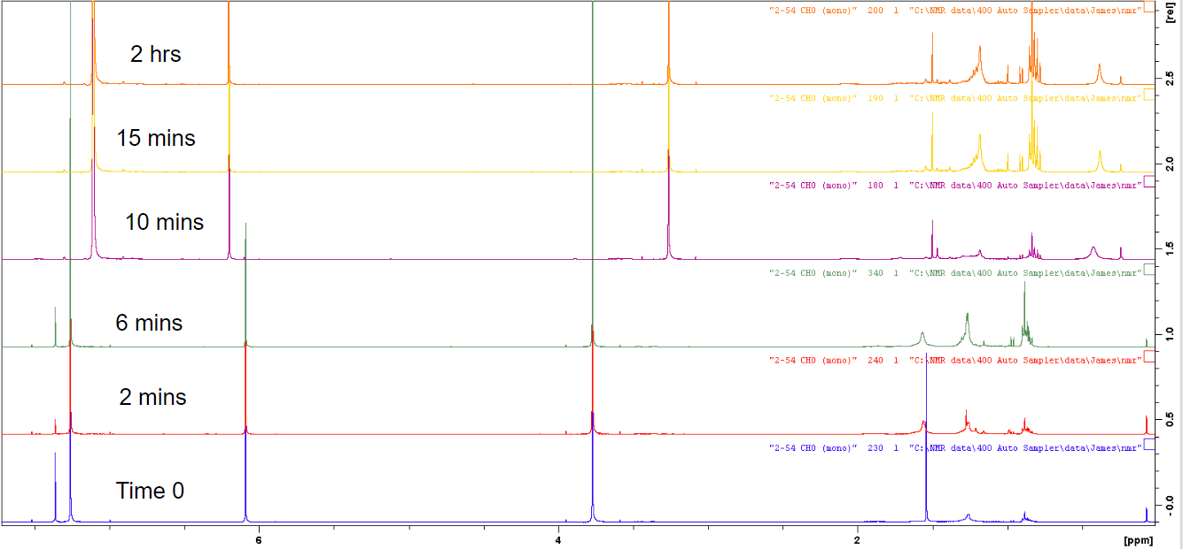

**M**

**S**

**S**

**S**

1H NMR (400 MHz, CDCl3, used C6D6 after 10 minutes ). (**M**:monomer; **S**:standard,trimethoxybenzene; **P**:polymer). (time:conversion%): 2hours:0%

***Cyclohexene Oxide (oxidized)***

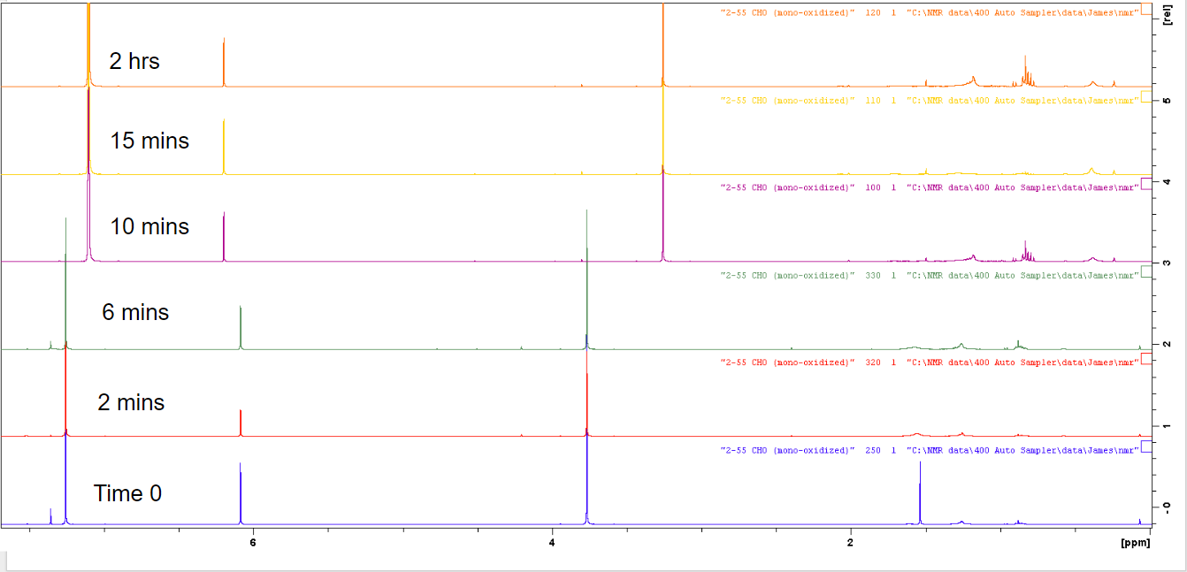

**M**

**S**

**S**

**S**

1H NMR (400 MHz, CDCl3, used C6D6 after 10 minutes ). (**M**:monomer; **S**:standard,trimethoxybenzene; **P**:polymer). (time:conversion%): 2hours:0%

***Styrene Oxide***

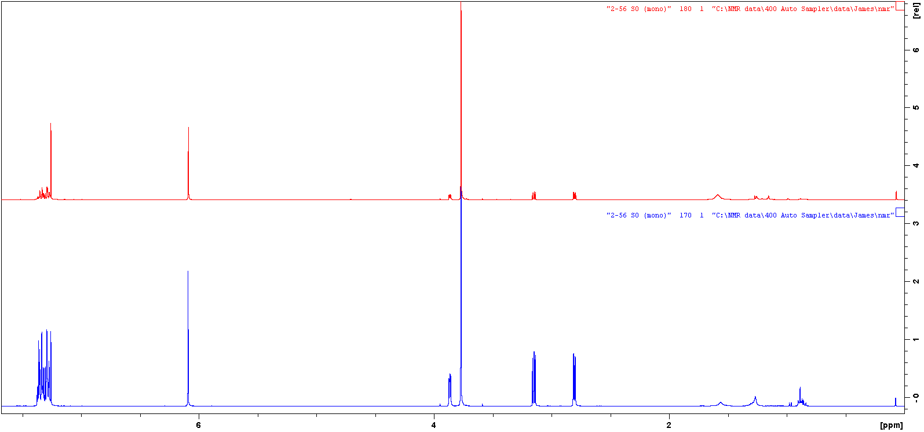

**M**

**M**

**S**

**M**

**S**

2 hrs

Time 0

1H NMR (400 MHz, CDCl3). (**M**:monomer; **S**:standard,trimethoxybenzene; **P**:polymer). (time:conversion%): 2hours:0%

***Styrene Oxide (oxidized)***

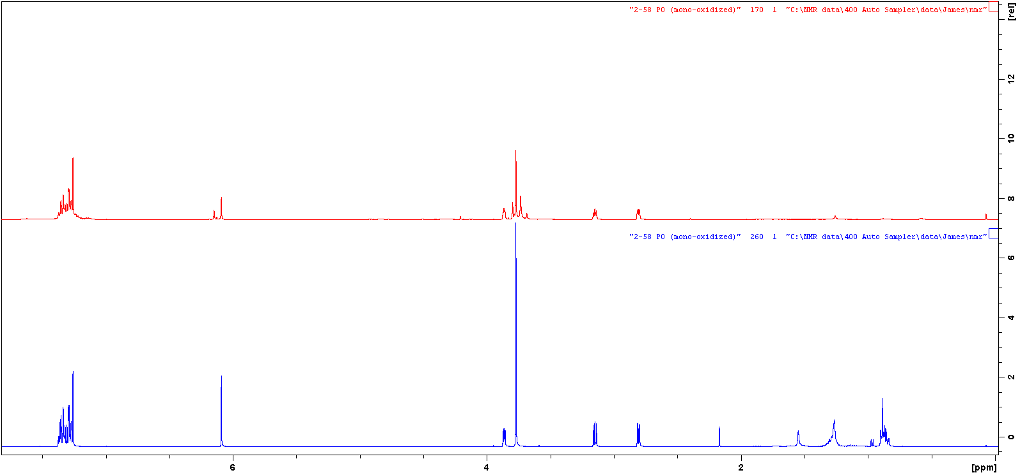

2 hrs

Time 0

**M**

**S**

**S**

**M**

**M**

1H NMR (400 MHz, CDCl3). (**M**:monomer; **S**:standard,trimethoxybenzene; **P**:polymer). (time:conversion%): 2hours:0%

***Propylene Oxide***

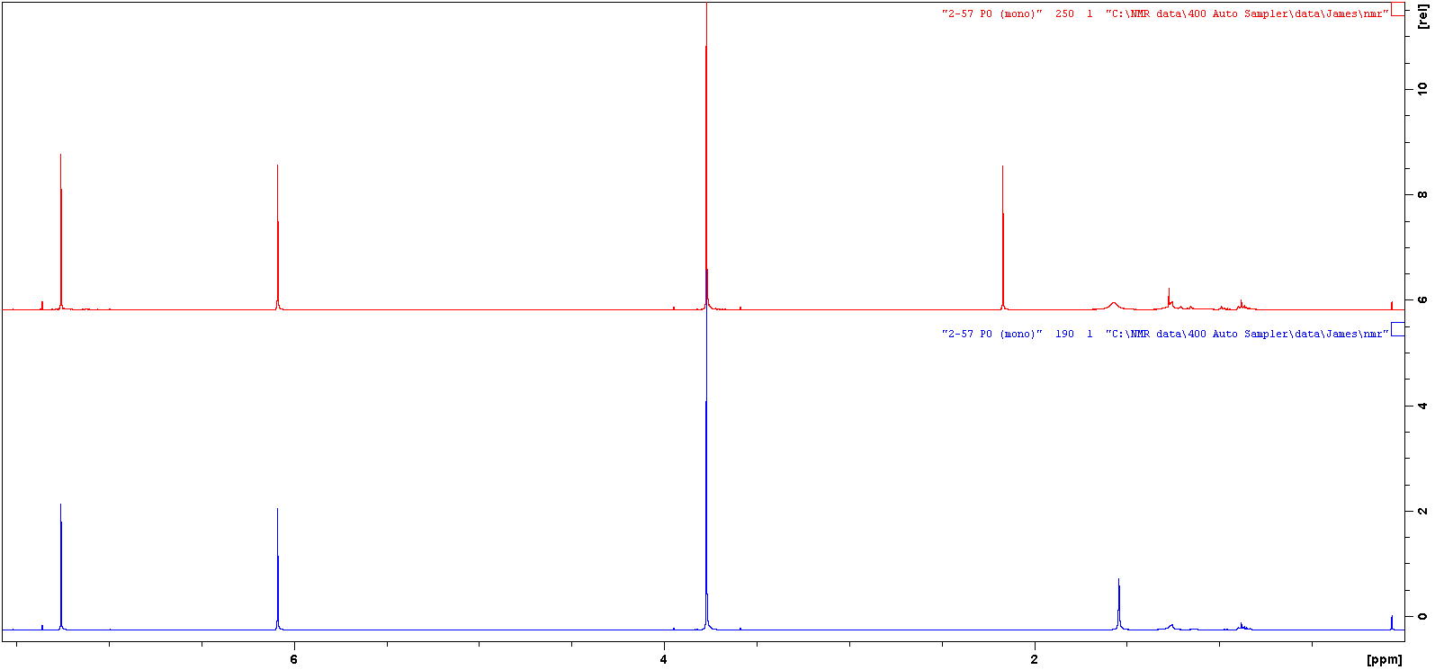

**S**

**S**

Time 0

2 hrs

1H NMR (400 MHz, CDCl3). (**M**:monomer; **S**:standard,trimethoxybenzene; **P**:polymer). (time:conversion%): 2hours:0%. Monomer was removed via vacuo.

***Propylene Oxide (oxidized)***

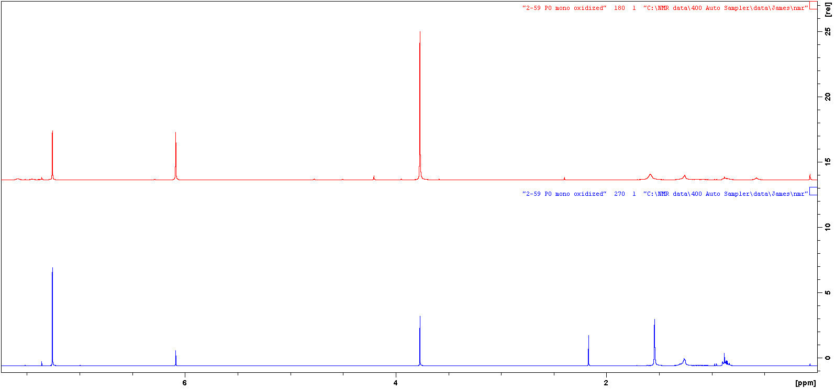

**S**

**S**

2 hrs

Time 0

1H NMR (400 MHz, CDCl3). (**M**:monomer; **S**:standard,trimethoxybenzene; **P**:polymer). (time:conversion%): 2hours:0%. Monomer was removed via vacuo.

***Beta-Butyrolactone***

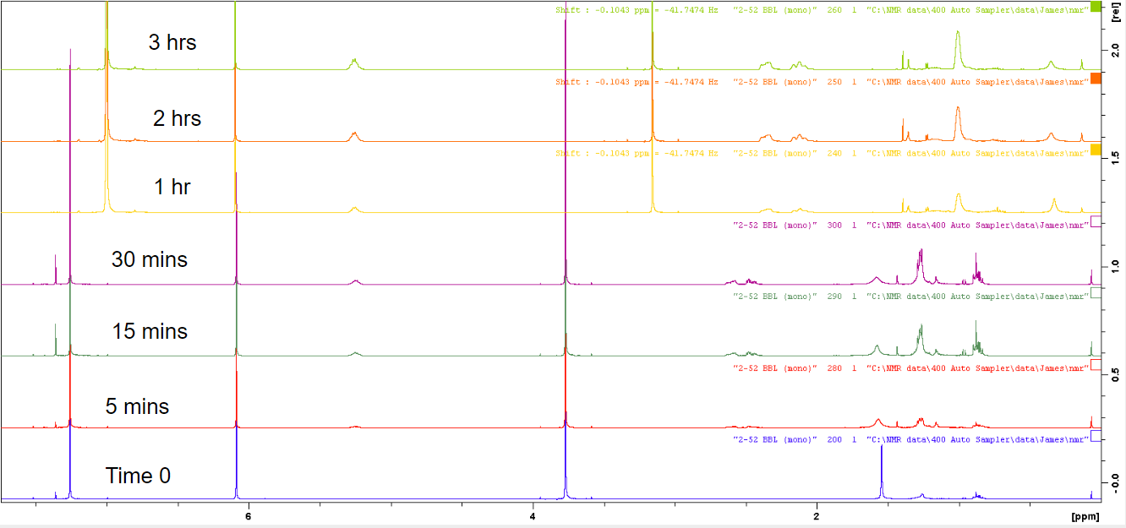

**P**

**P**

**P**

**S**

**S**

**S**

v

1H NMR (400 MHz, CDCl3, used C6D6 after 30 minutes ). (**M**:monomer; **S**:standard,trimethoxybenzene; **P**:polymer). (time:conversion%): 2hours:100%.

***Beta-Butyrolactone (oxidized)***

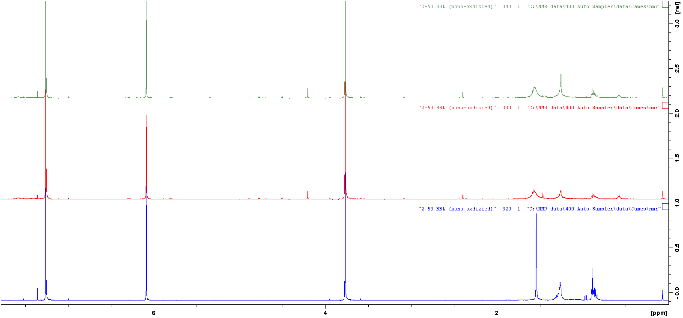

**S**

**S**

20 mins

5 mins

Time 0

1H NMR (400 MHz, CDCl3, used C6D6 after 30 minutes ). (**M**:monomer; **S**:standard,trimethoxybenzene; **P**:polymer). (time:conversion%): 20mins:0%

**References**

1. Dechy-Cabaret, Odile; Martin-Vaca. Blanca; Bourissou, Didier. Chem. Rev., **2004**, *104* (12), pp 6147–6176
2. Broderick, Erin M.; Guo, Neng; Vogel, Carola; Xu, Cuiling; Sutter, Jorg; Miller, Jeffrey T.; Meyer, Karsten; Mehrkhodavandi, Parisa; Diaconescu, Paula L. *J. Am. Chem. Soc.* **2011**, *133(24)*, 9278-9281.
3. Teator, Aaron J.; Lastovickova, Dominika N.; Bielawski, Christopher W. Chem. Rev., **2016**, *116* (4), pp 1969–1992